* 5560802 SD Portal S SD Portal SD Portal - Ensure user able to update the Maintenance (Product).

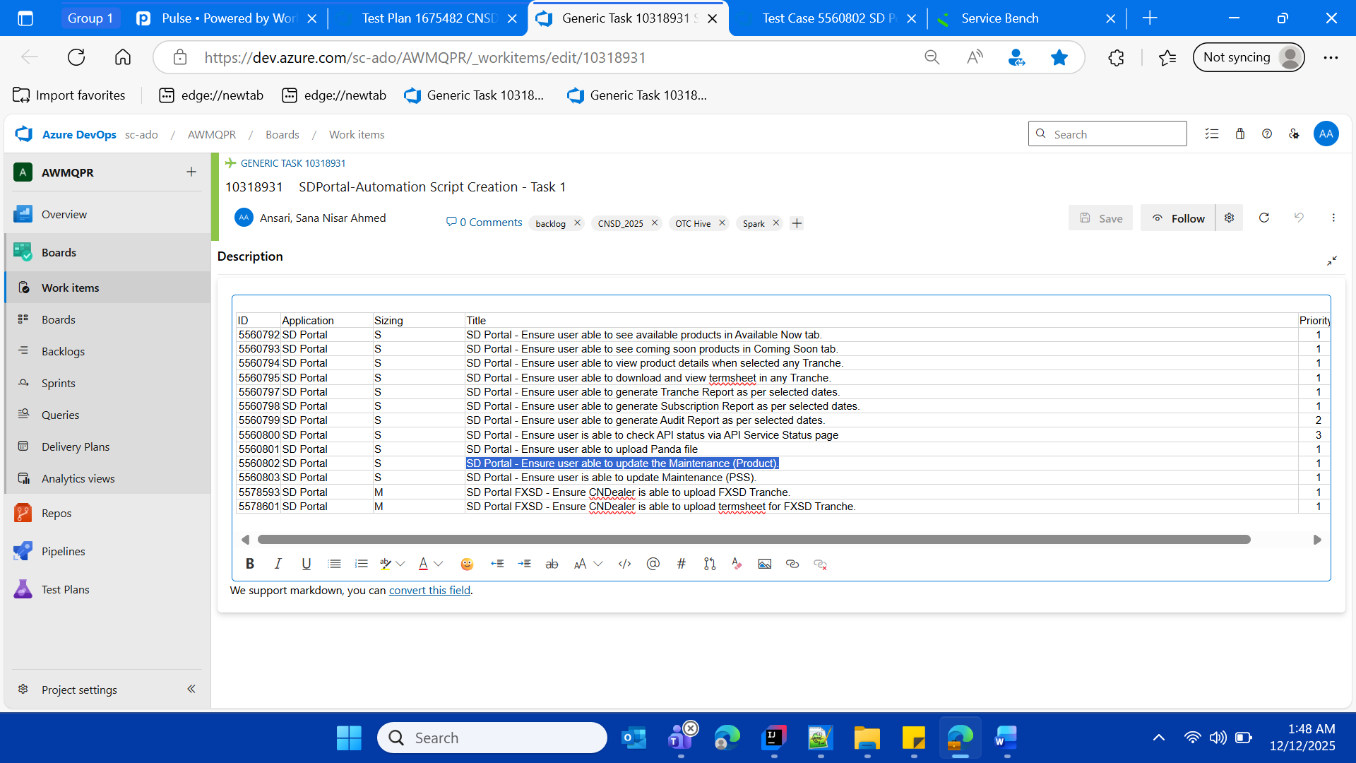

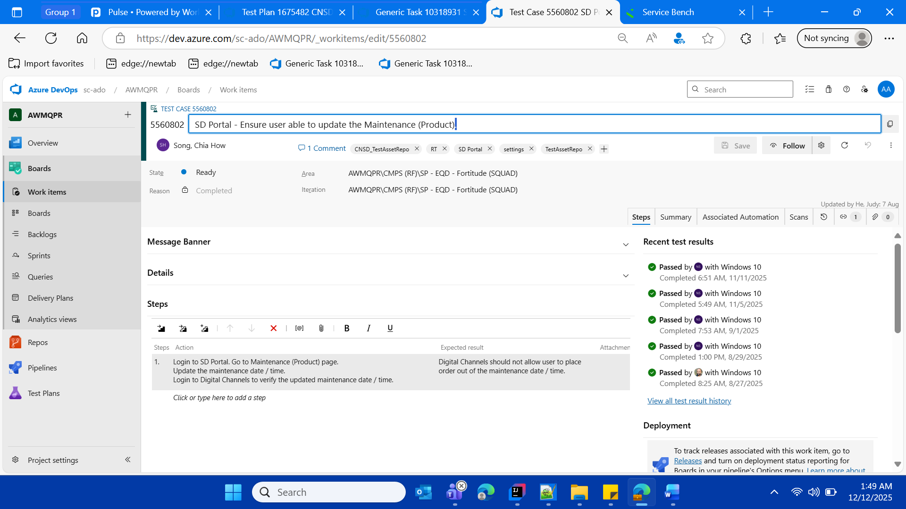



SDPortal New Dev URL

https://cnlvadeqc001.cn.standardchartered.com:8463/wm/full/cnsd/index2.html#/rmp/login

User ID-User Role (Checker / Maker)

1568256-CNDealer/Maker

1640499-CNProduct/Checker

Password (with LDAP)

SCBpassword5$

* **GENERAL SERVICE HOURS**

Launch URL via already available background SD Portal (as per the login test case which is already implemented with the CNSD FW, so resue)

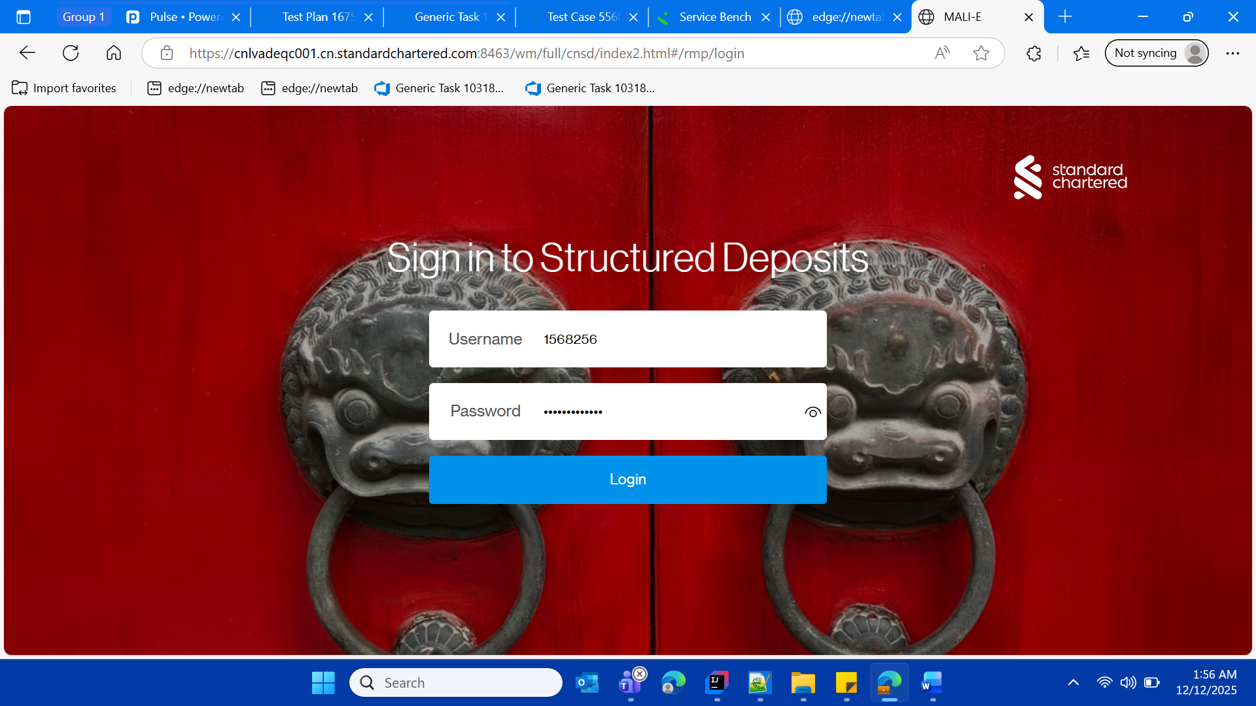

Enter Maker User Name and Password



Wait and CNDealer/Maker lands on the home page with product catalogue Dashboard

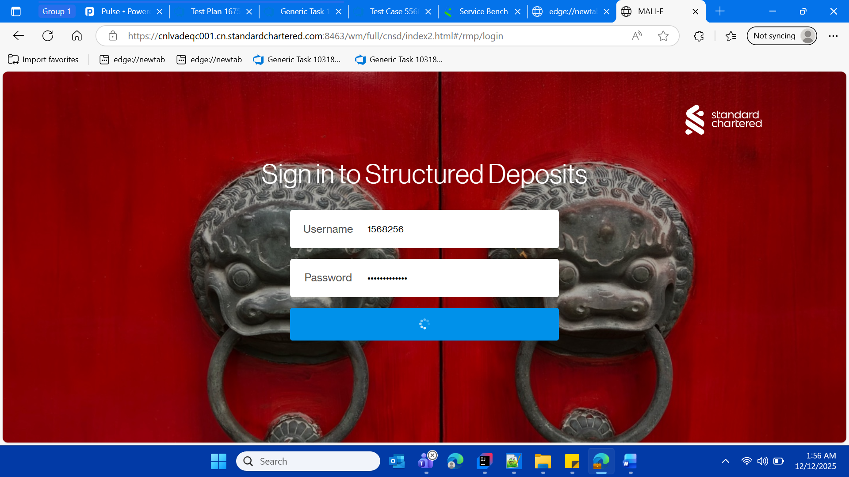

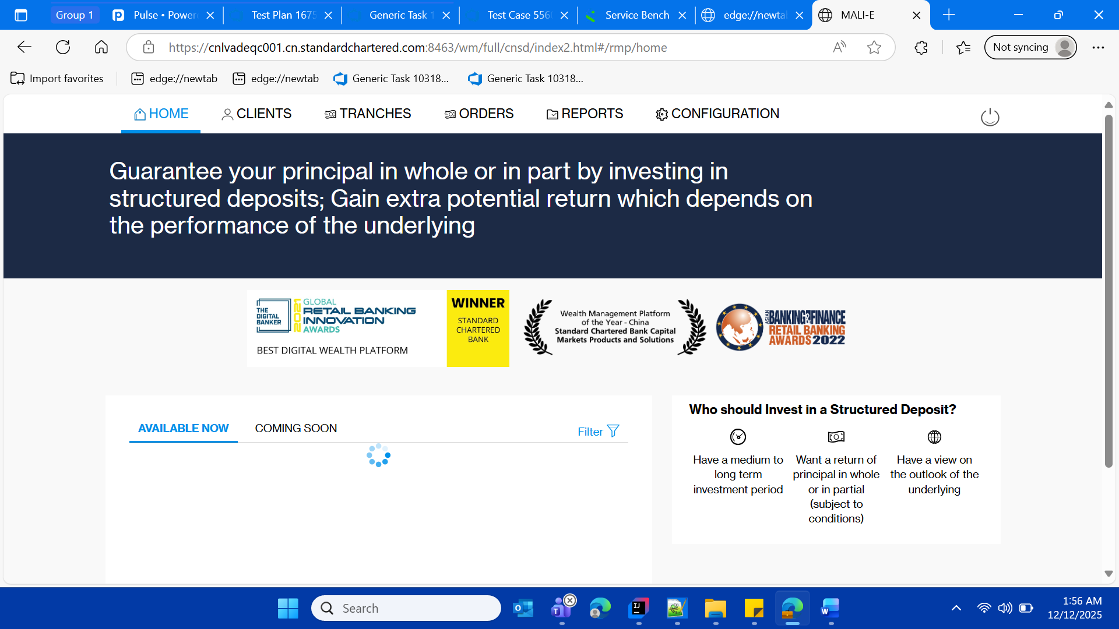

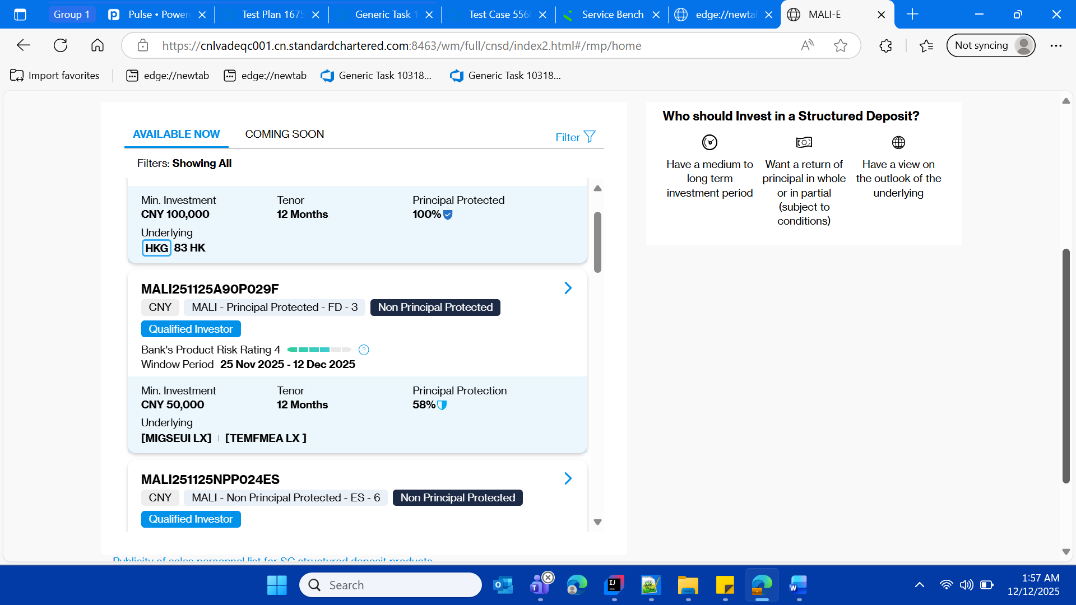

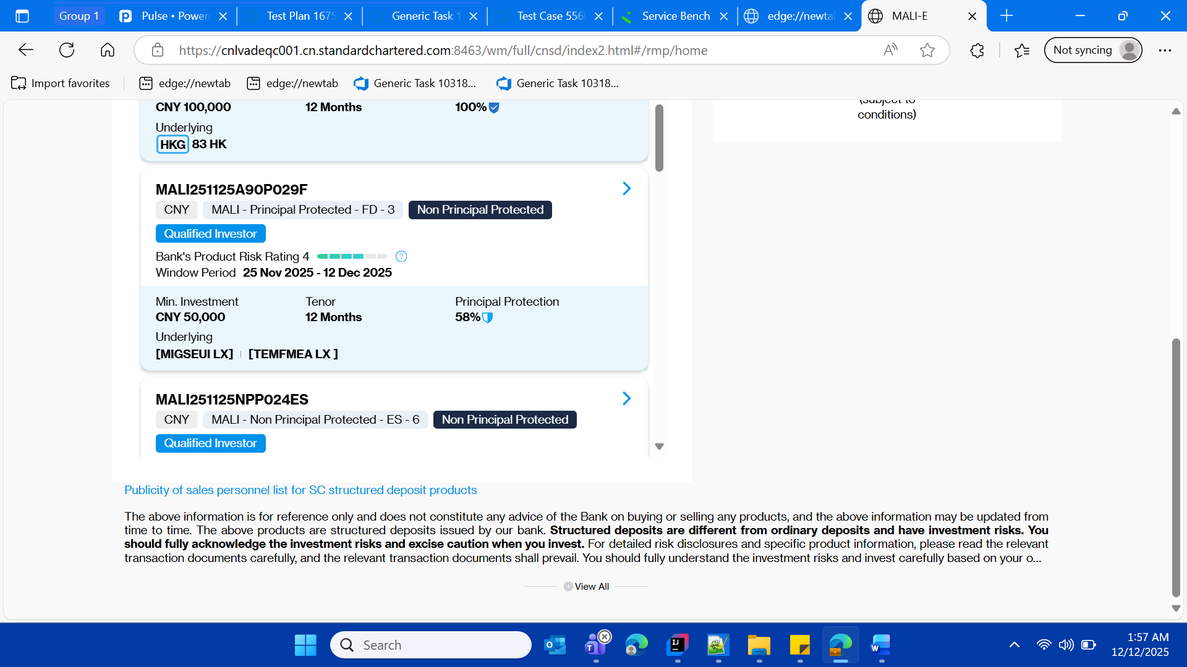



* Click on the Configuration Tab/Page

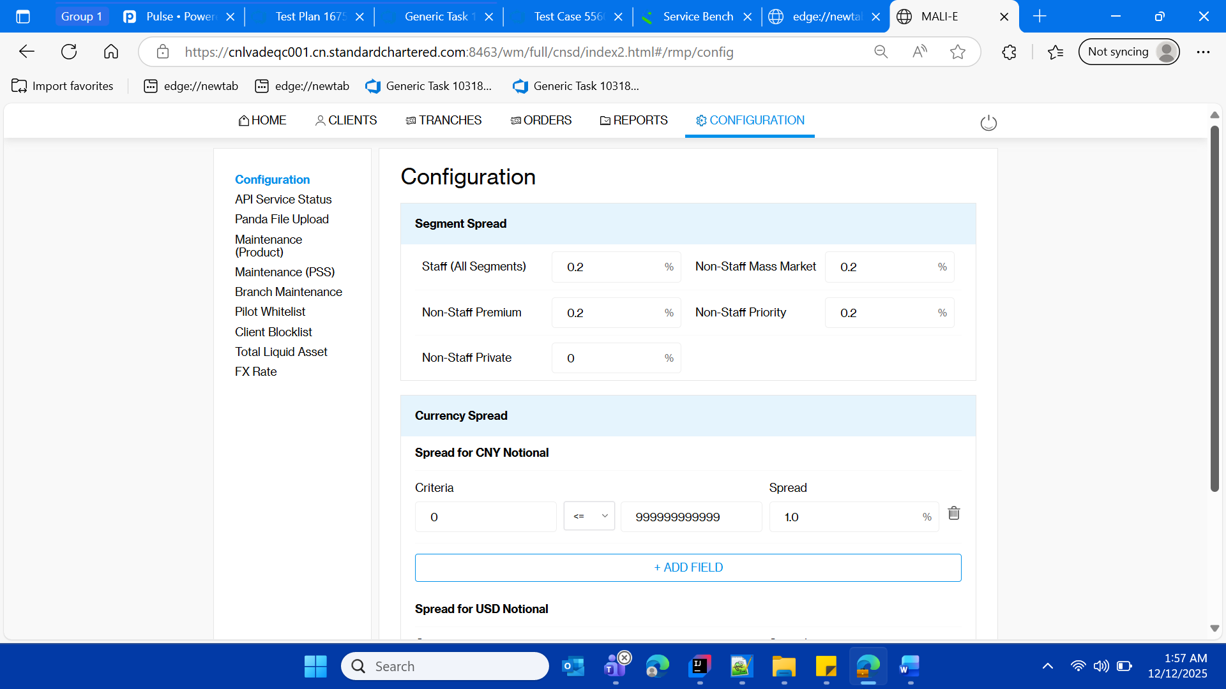

* Click on “Maintenance Product ” Left menu

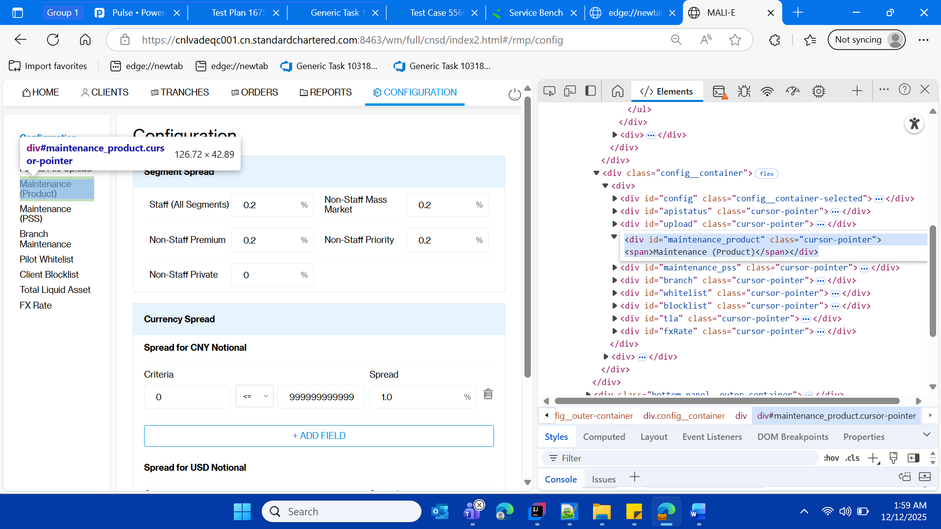

* Verify the maintenance product title
* Verify the functionality of general service hour for Friday(or any day)

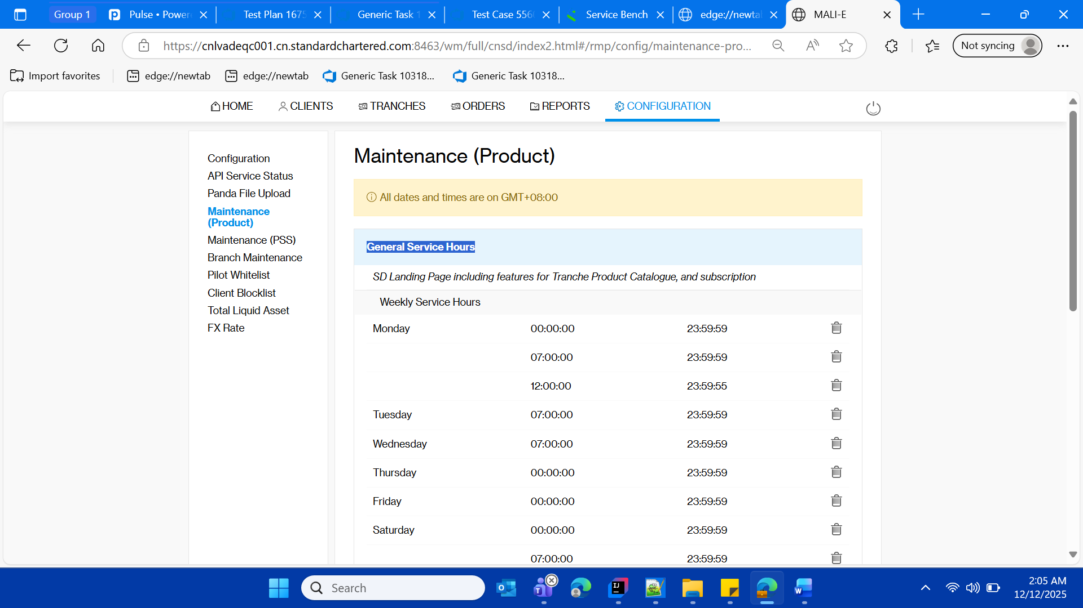

* Delete the Friday row for general service hours section

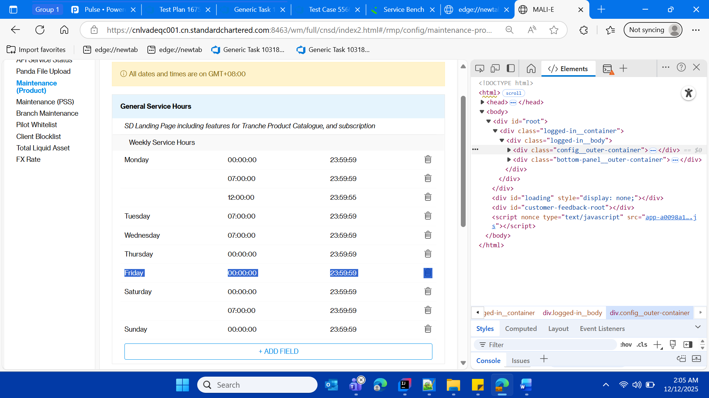

* Validate After delete of Friday row from general service hours

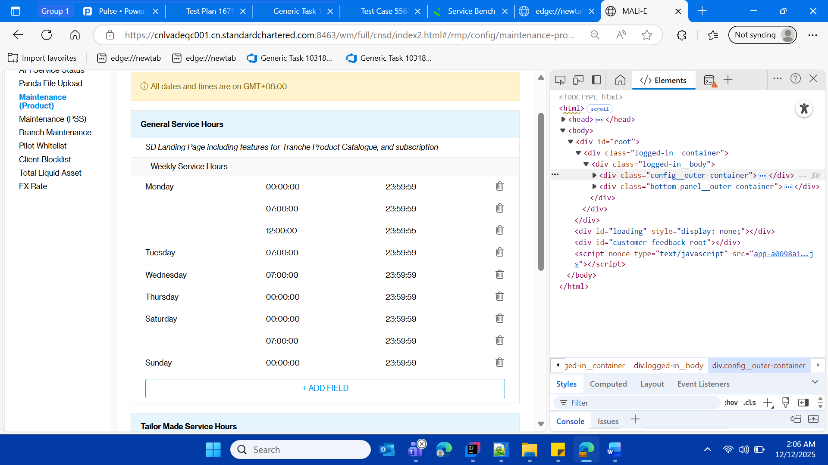

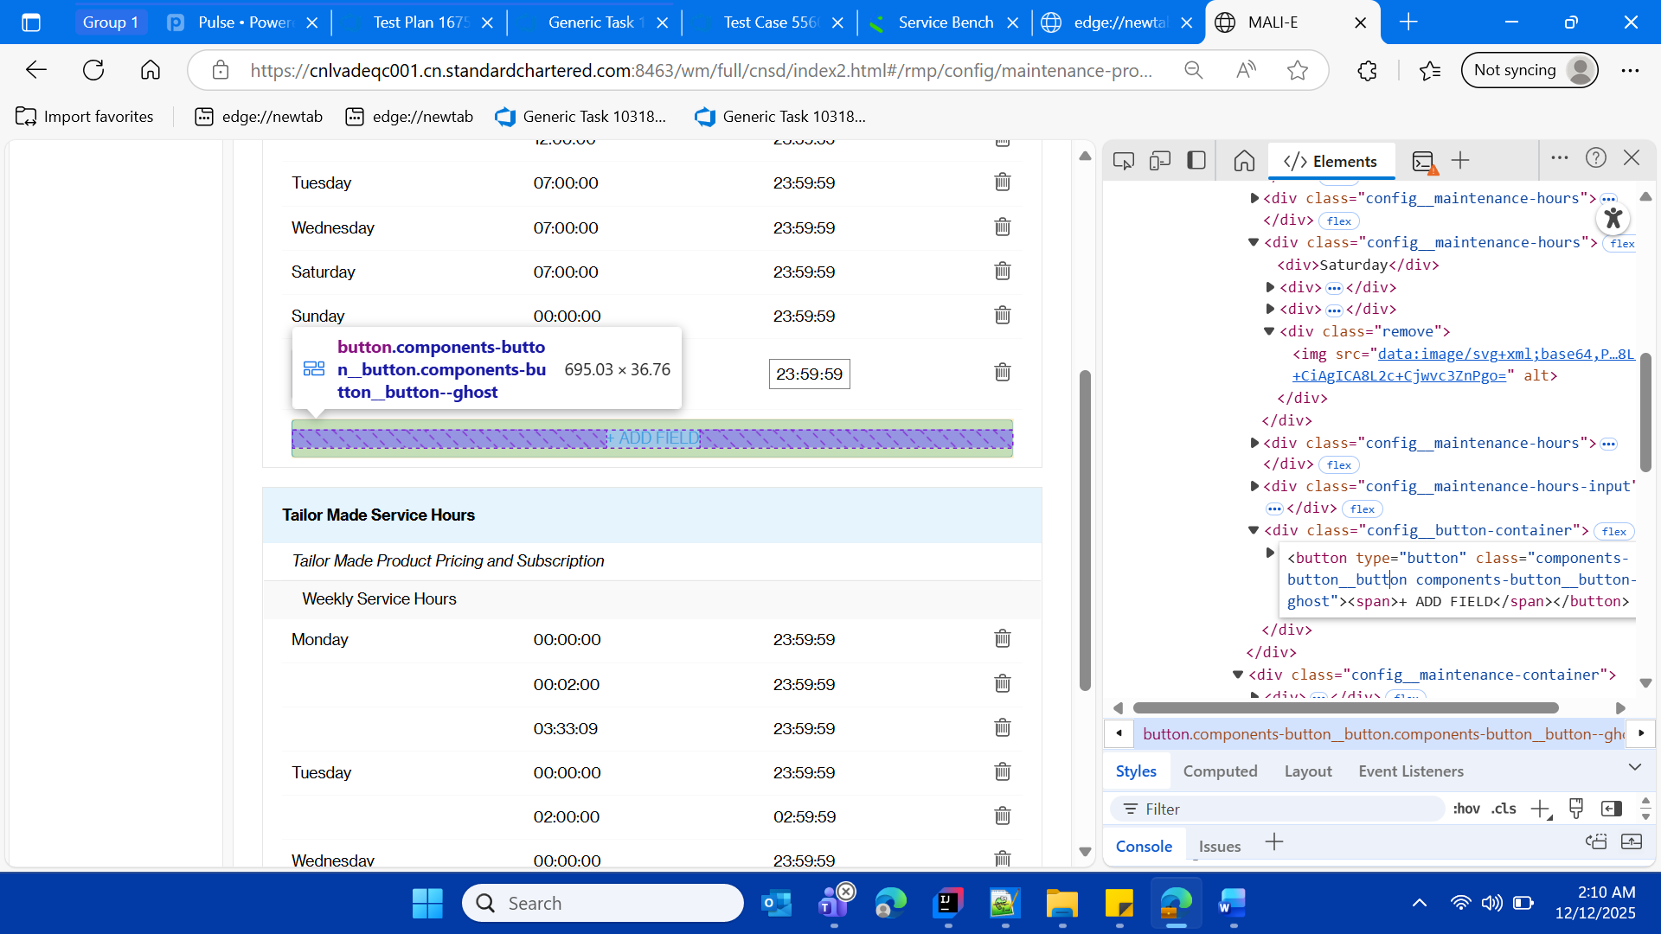

* create the new row entry for general service hours for Friday via “Add Field ” button

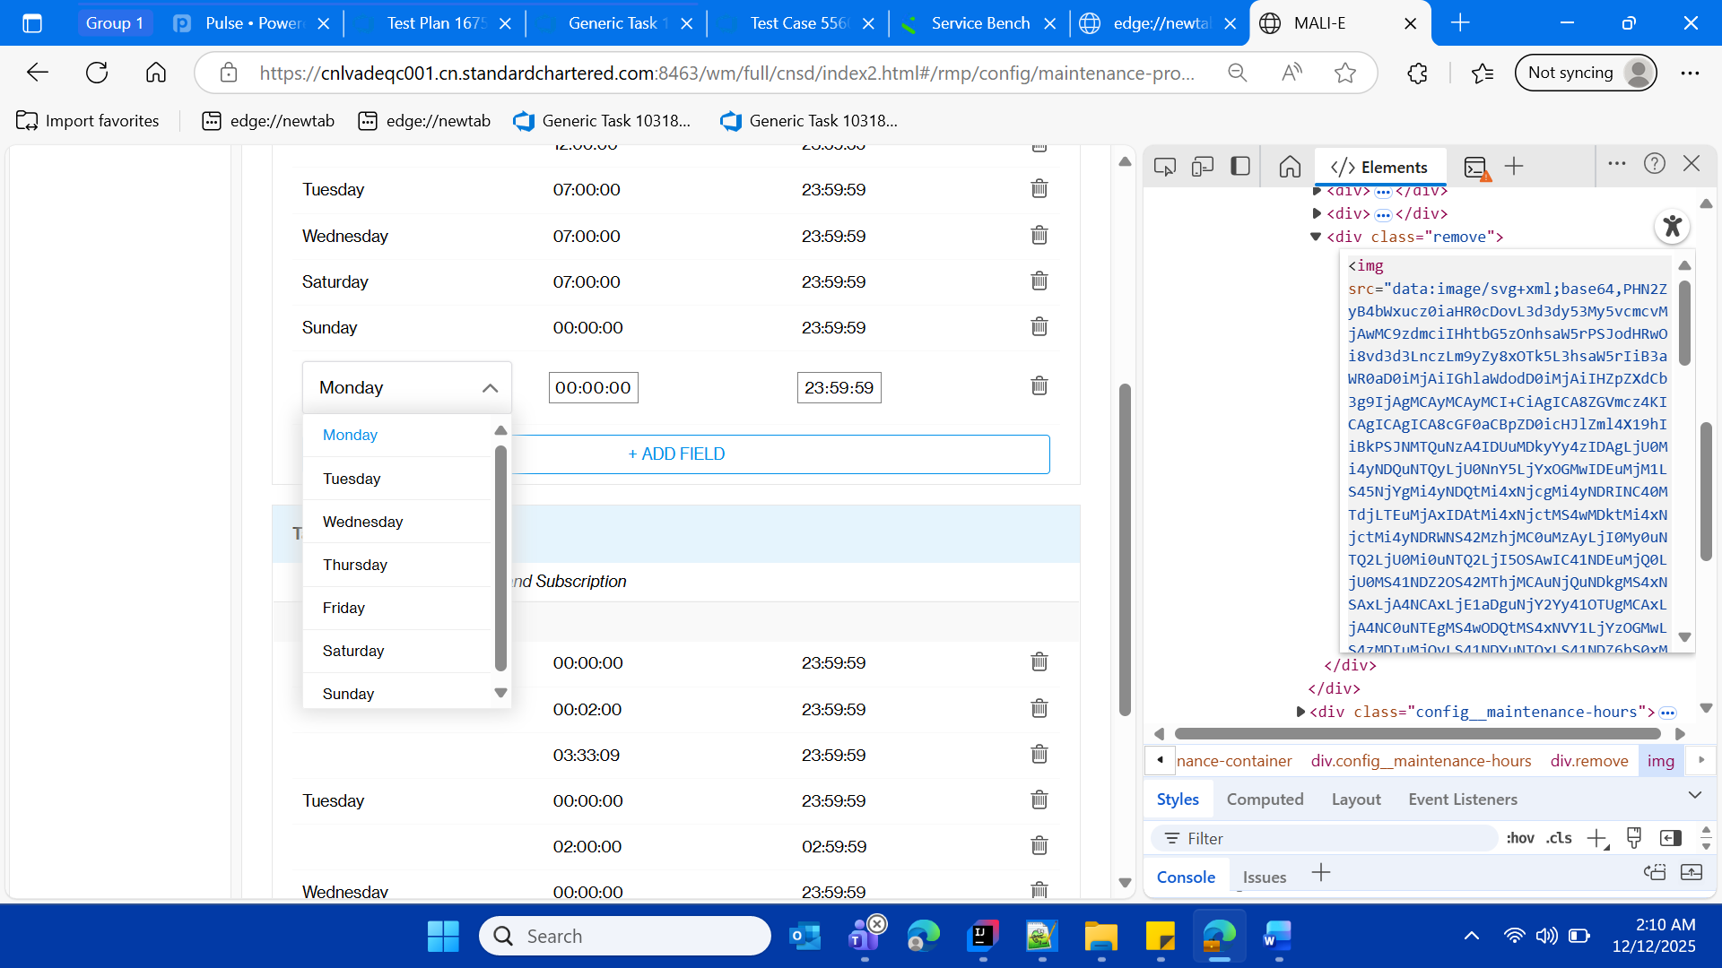

* Select Friday from the dropdown

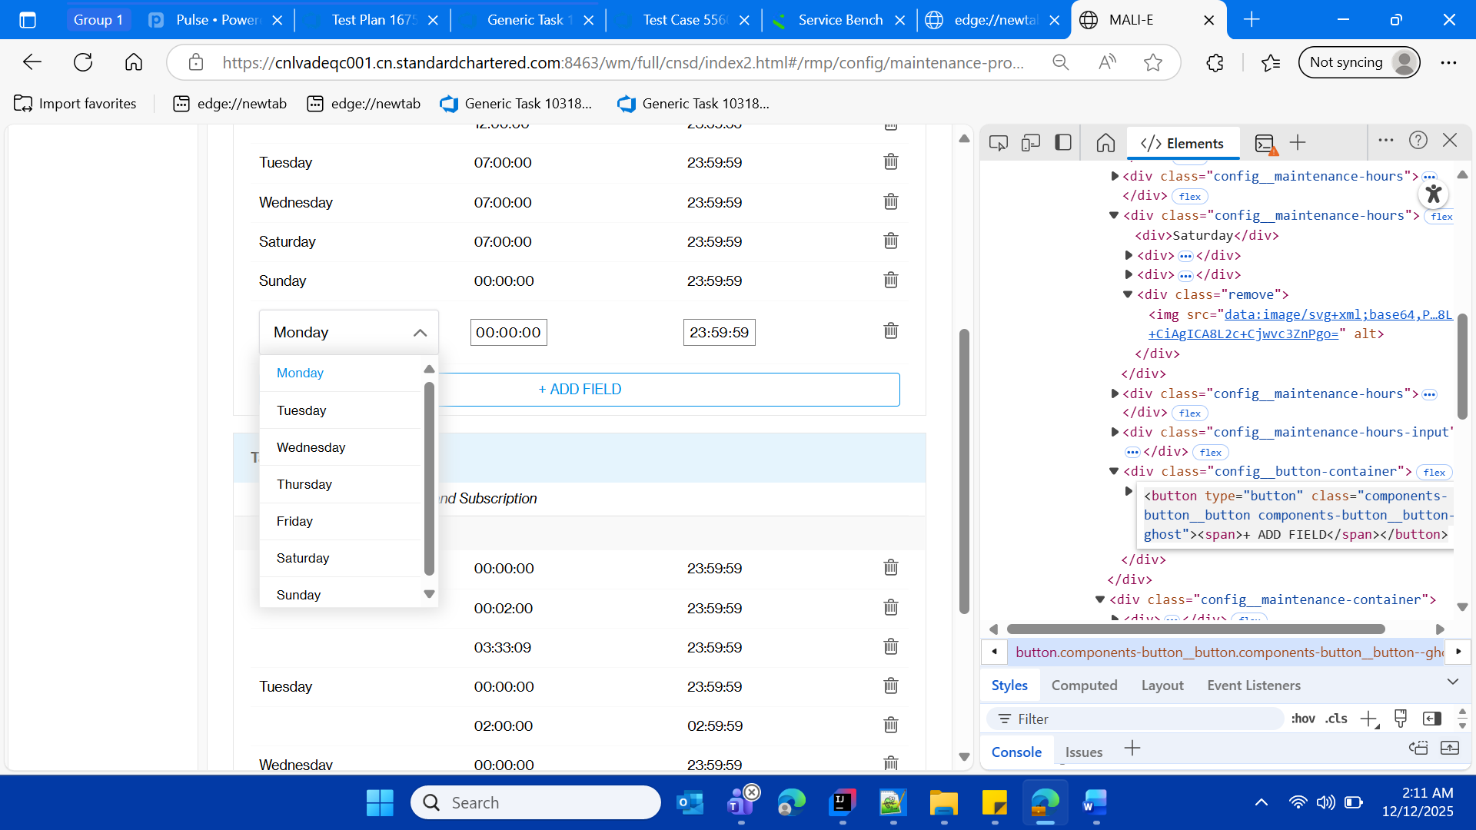

* Verify the default time for the Friday dropdown

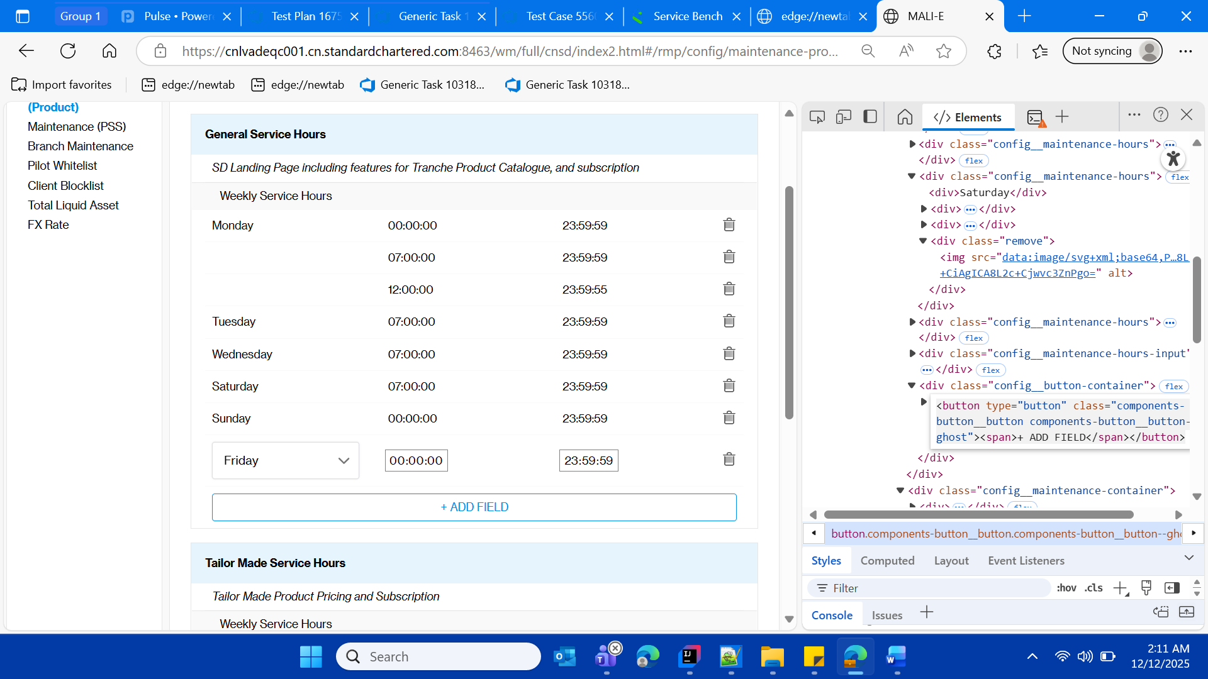

* Update from and to time for the Friday (date on which u are doing the execution of this test case)
* Now click on “Save changes” button

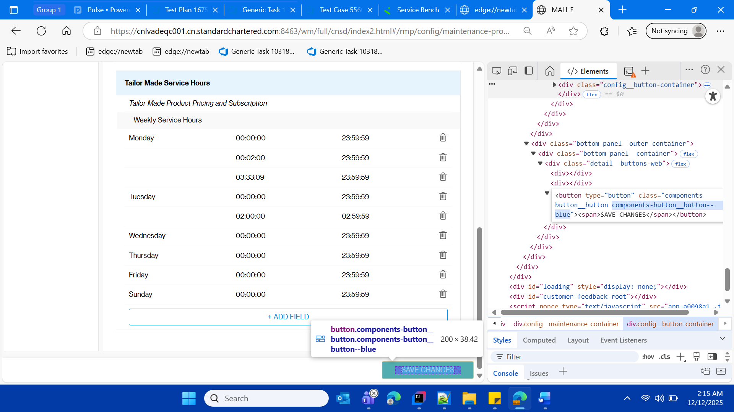

* Validate the success message

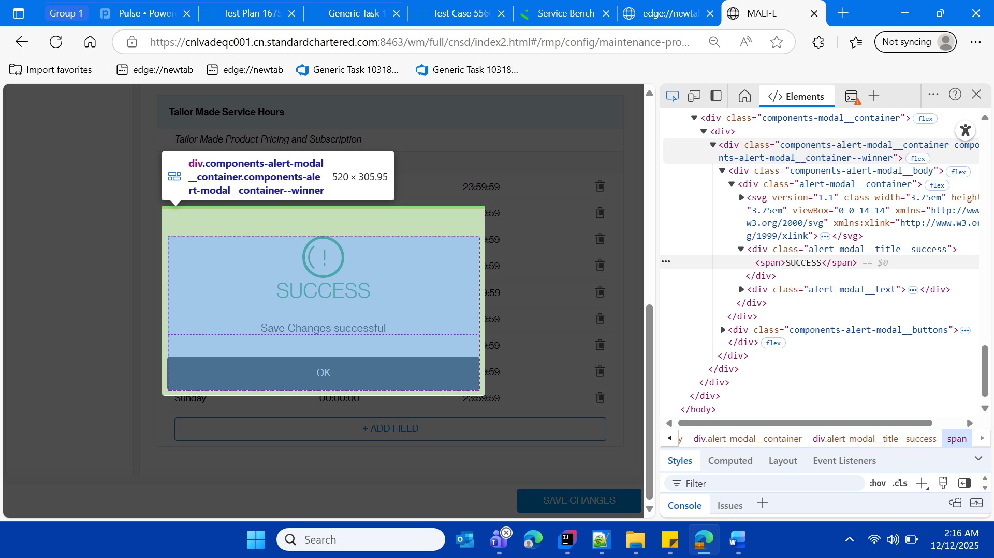

* Click on ok button

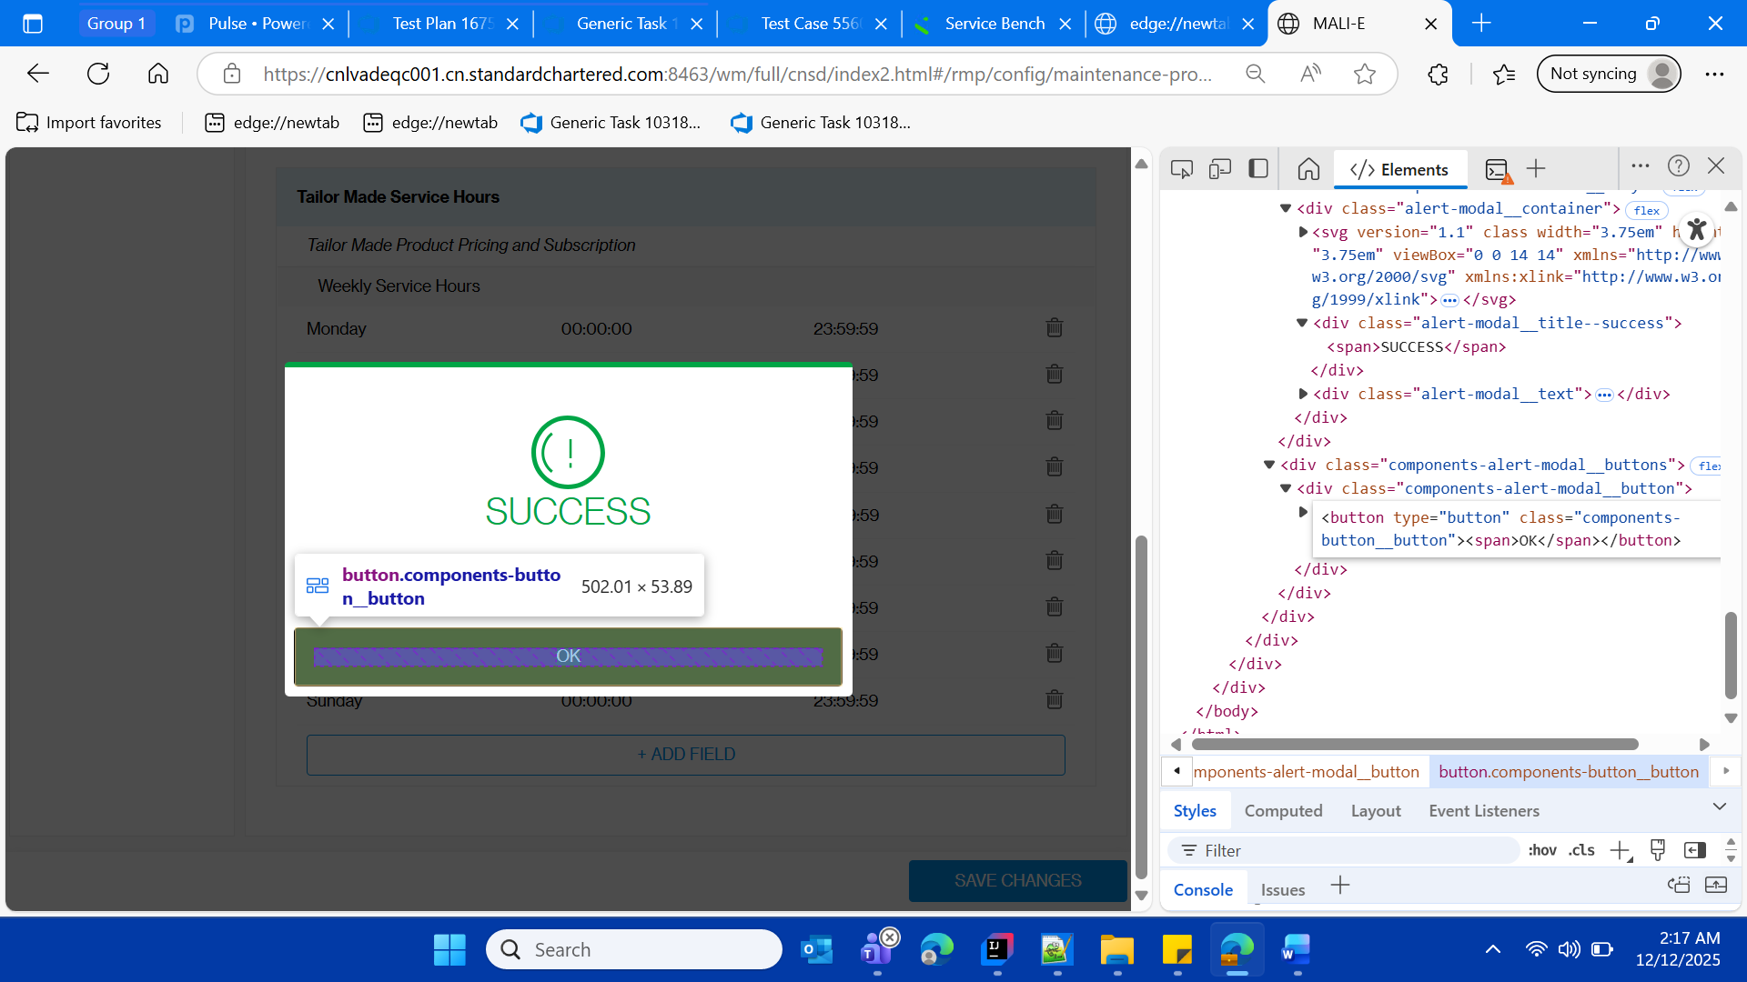

* Verify the entered Friday row

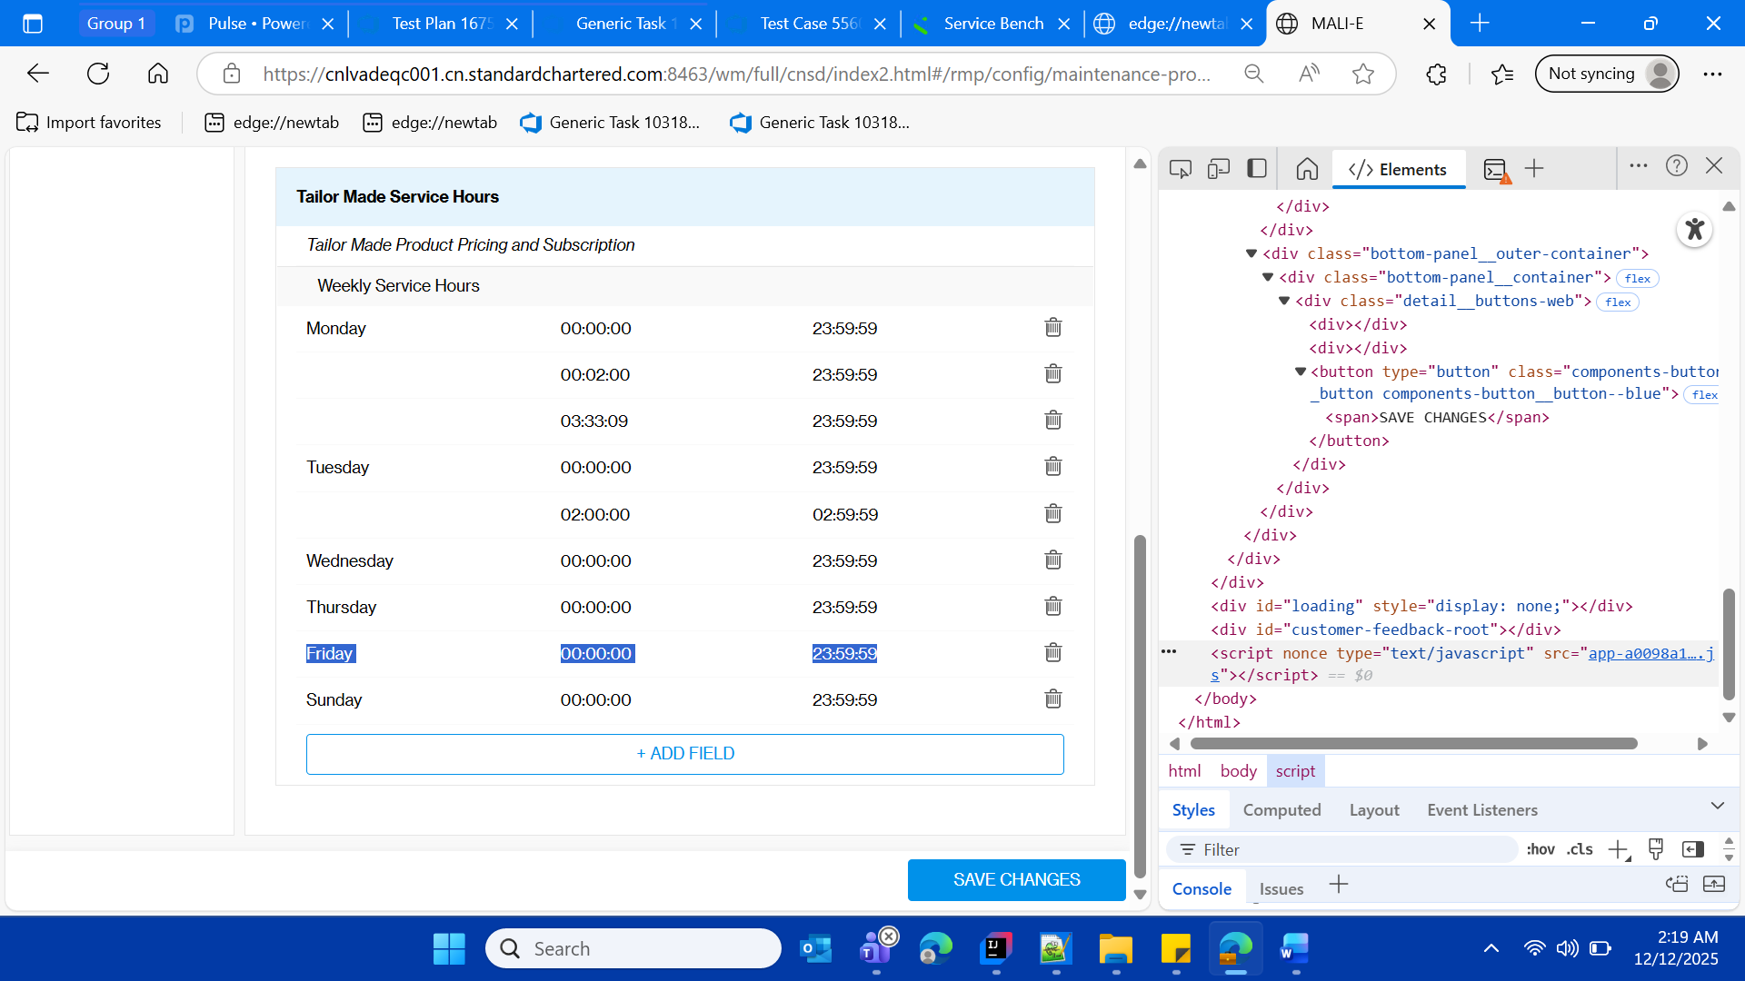

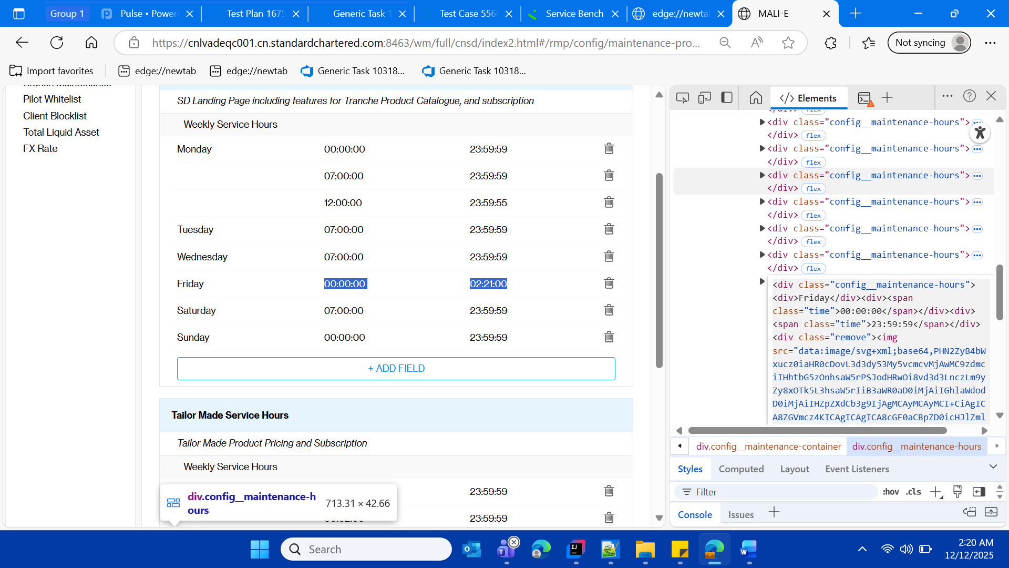

Login to sso mock with client id as 360297291 , select the language and channel as selected in below screenshot

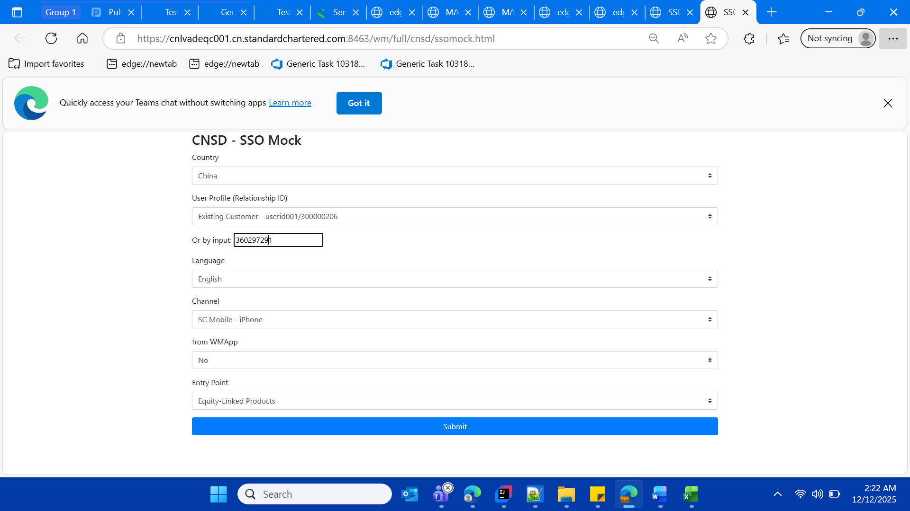

* Verify that after the to date which is for Friday 02:21 am , client should be able be see this pop up, verify the text message on pop up., due to which he os not able to access the Home(Product Catalogue) page of SSOMOCK(also called by name as SC MOBILE and CNSD)

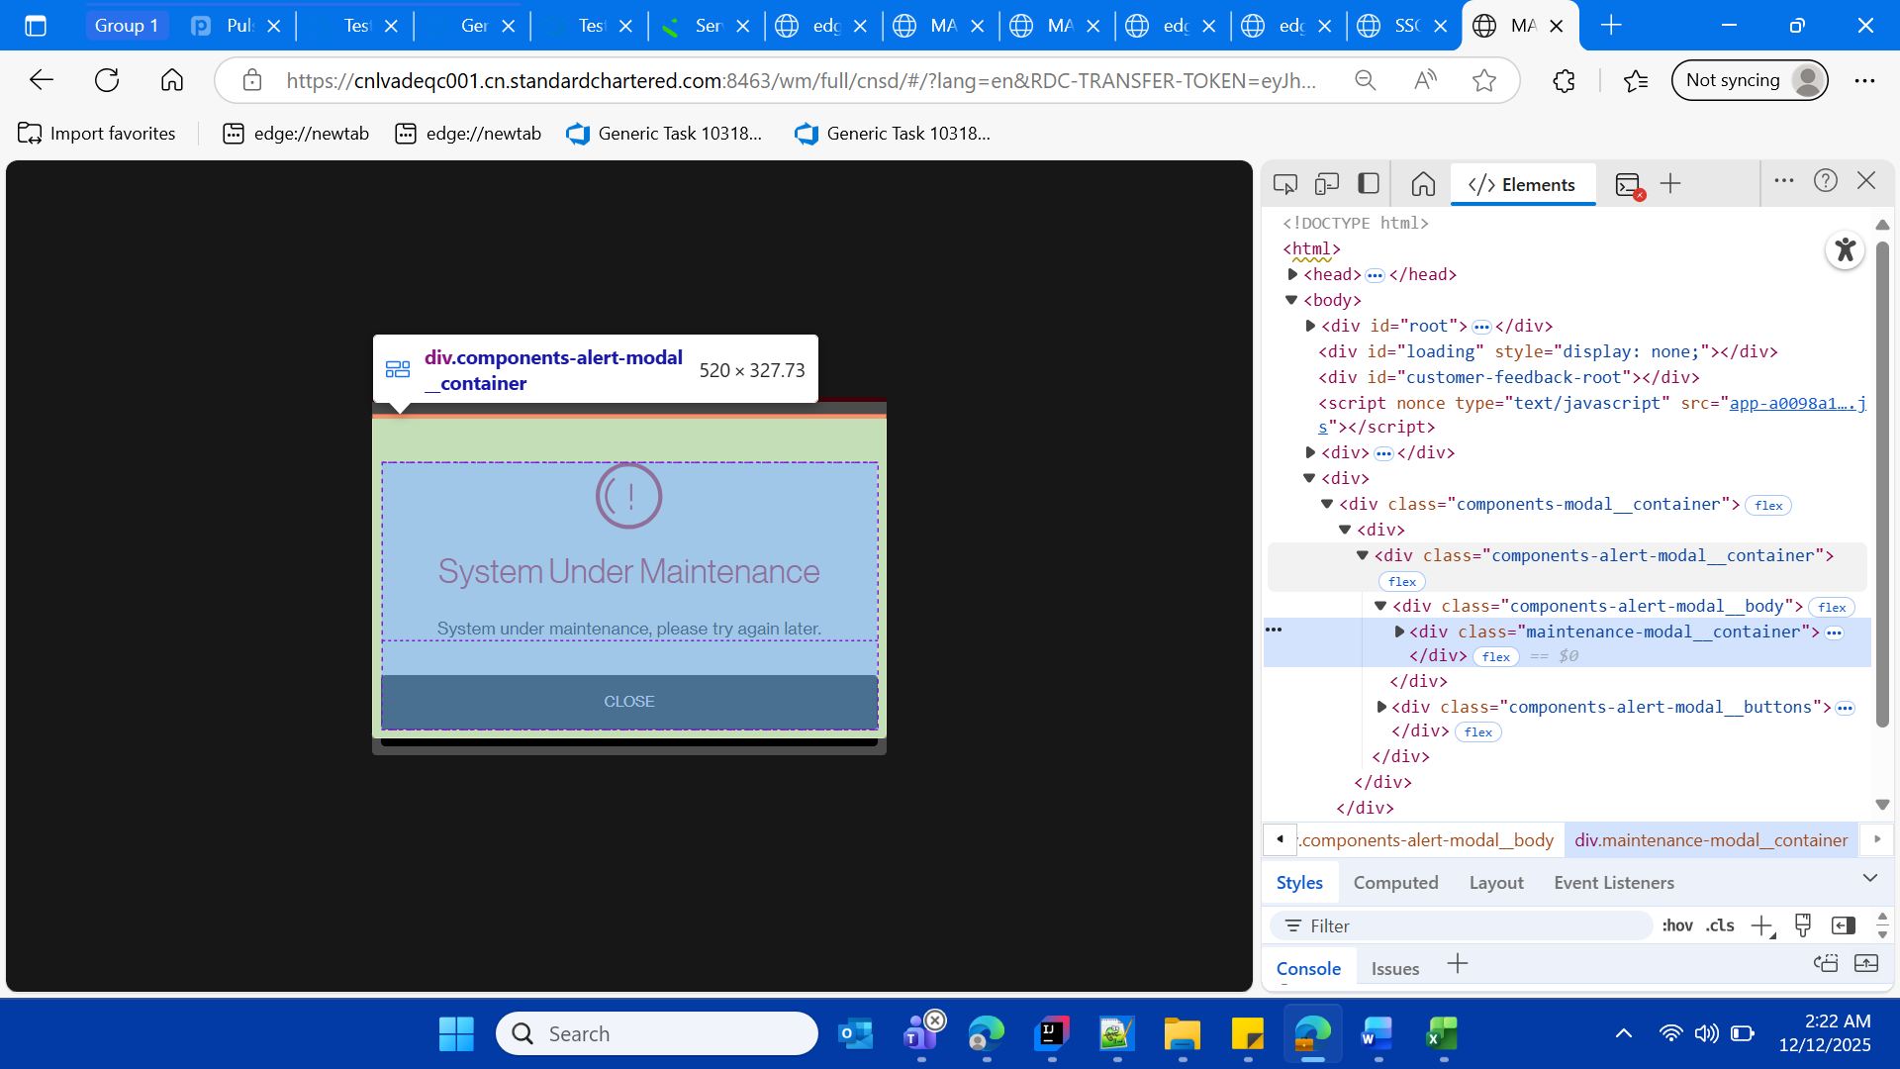

* Click on close button on maintenance pop up

After click on close button and then skip on the next pop up

Then close the child window of SSO MOCK app

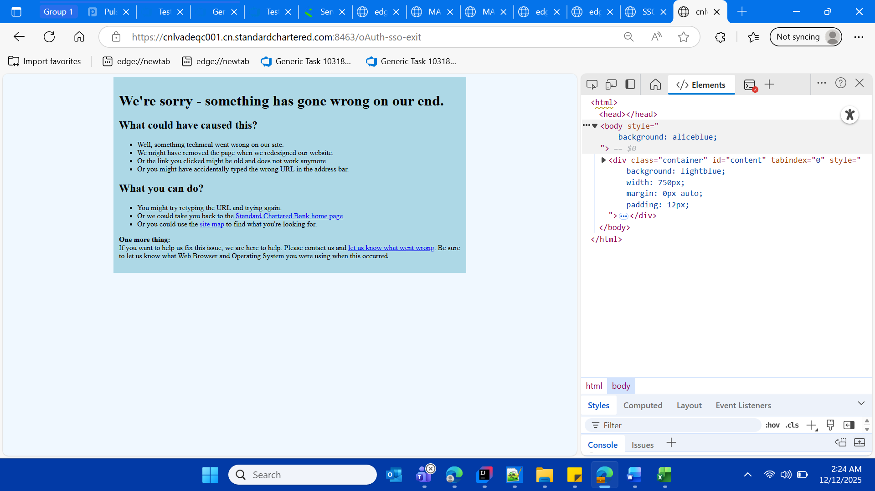

* Resetting application in its original state, for General Service hours.
* Login with maker login again and navigate to the configuration

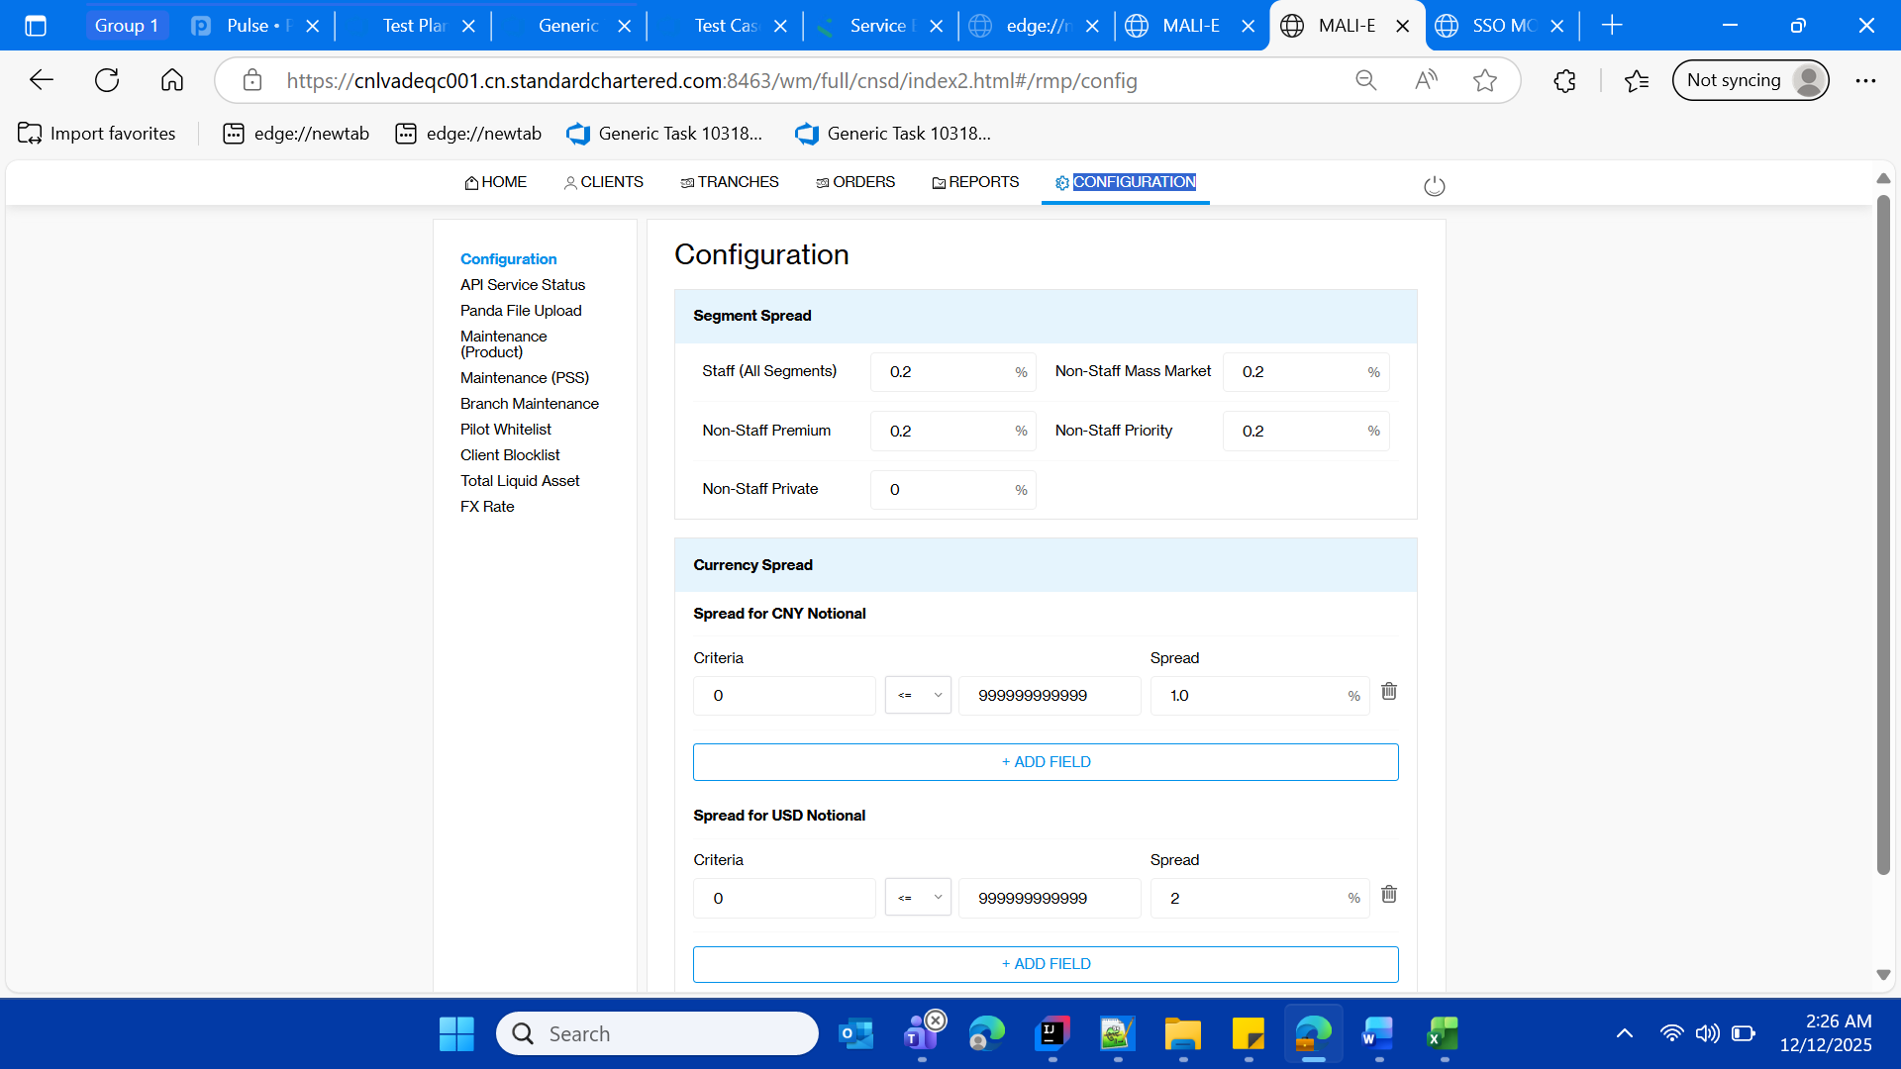

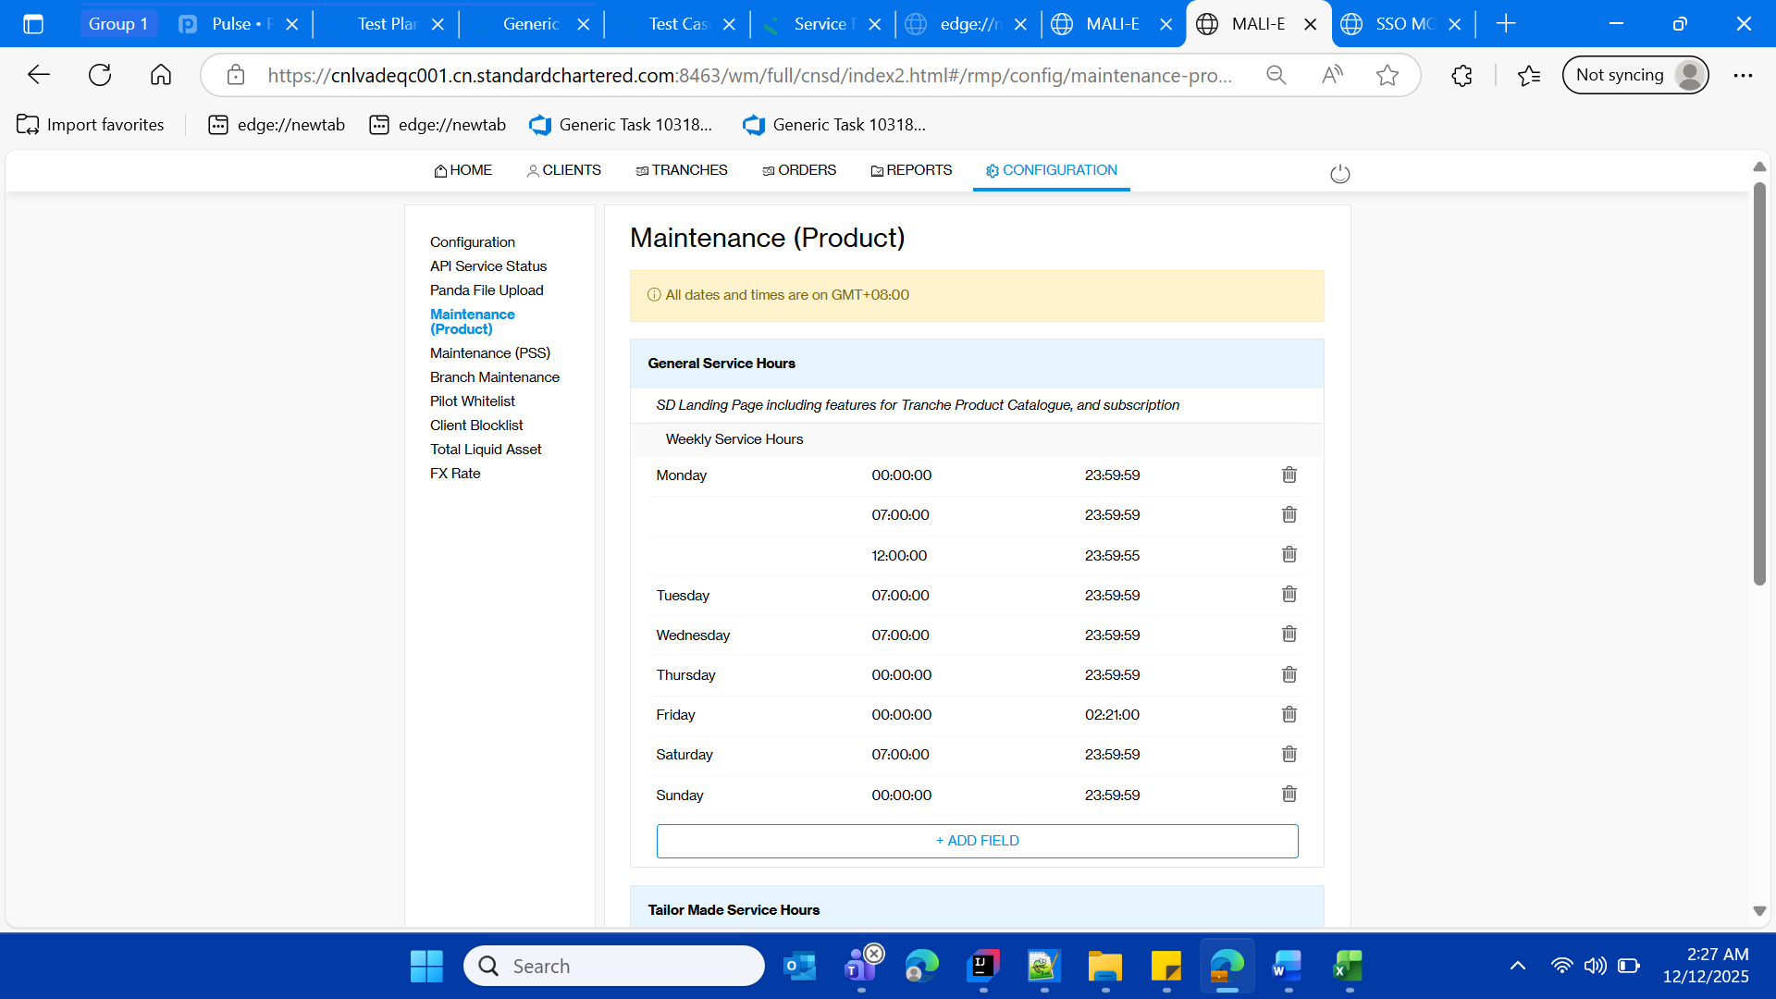

* Test the entered data in the original state



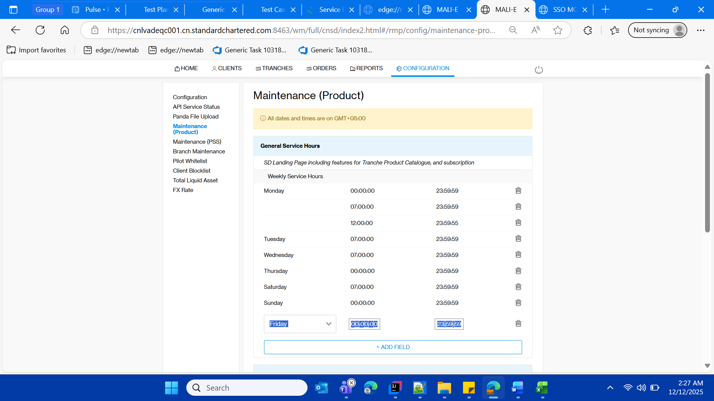

Validate success message

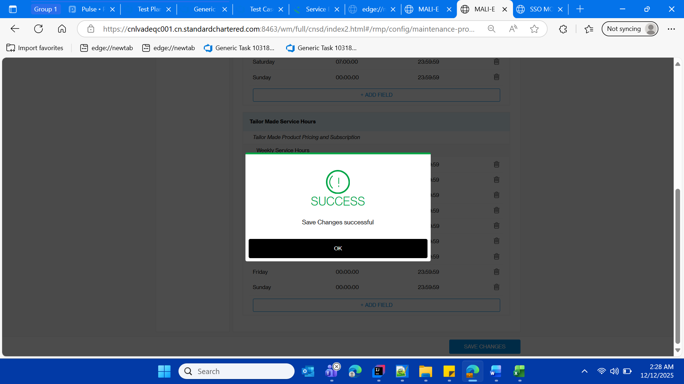

* Validate the original entered data



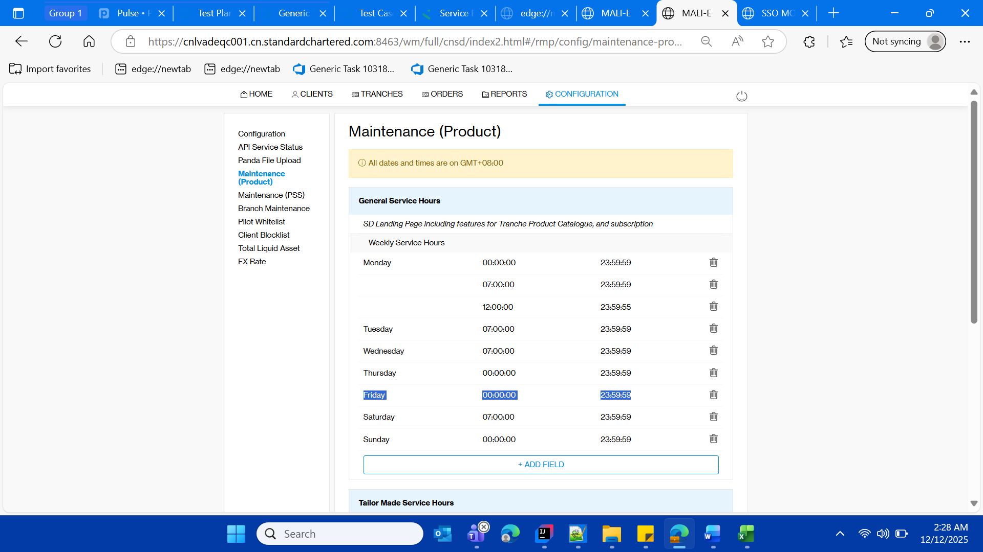

==== **Tailor-Made Structured Deposits====**

* **Login with maker login in SD Portal**

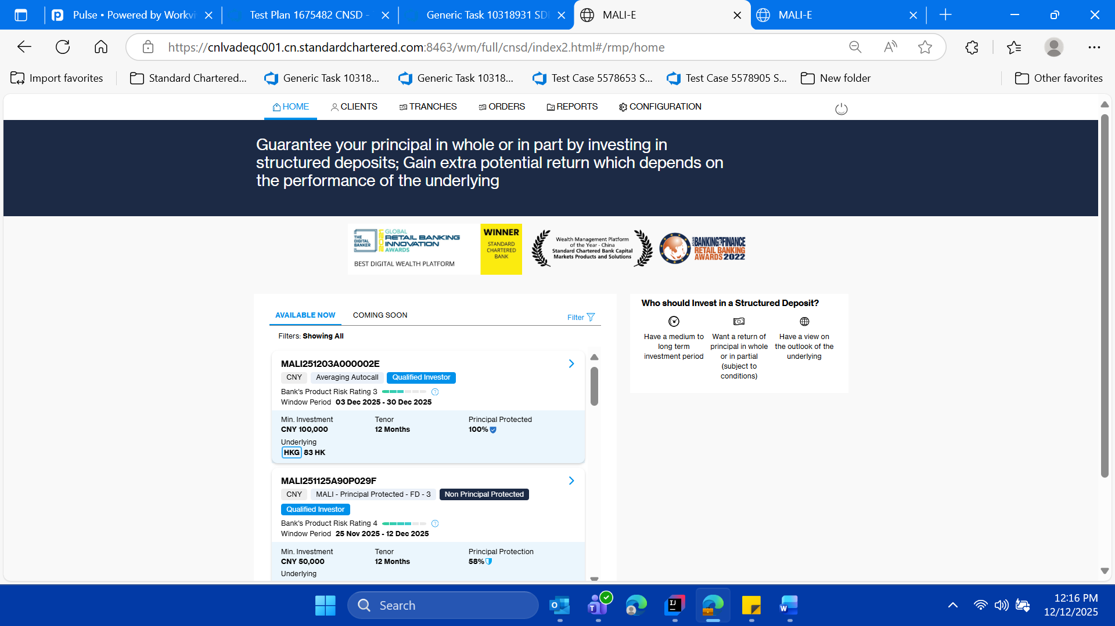

* **Click on the Configuration Tab/ and navigate to configuration page**

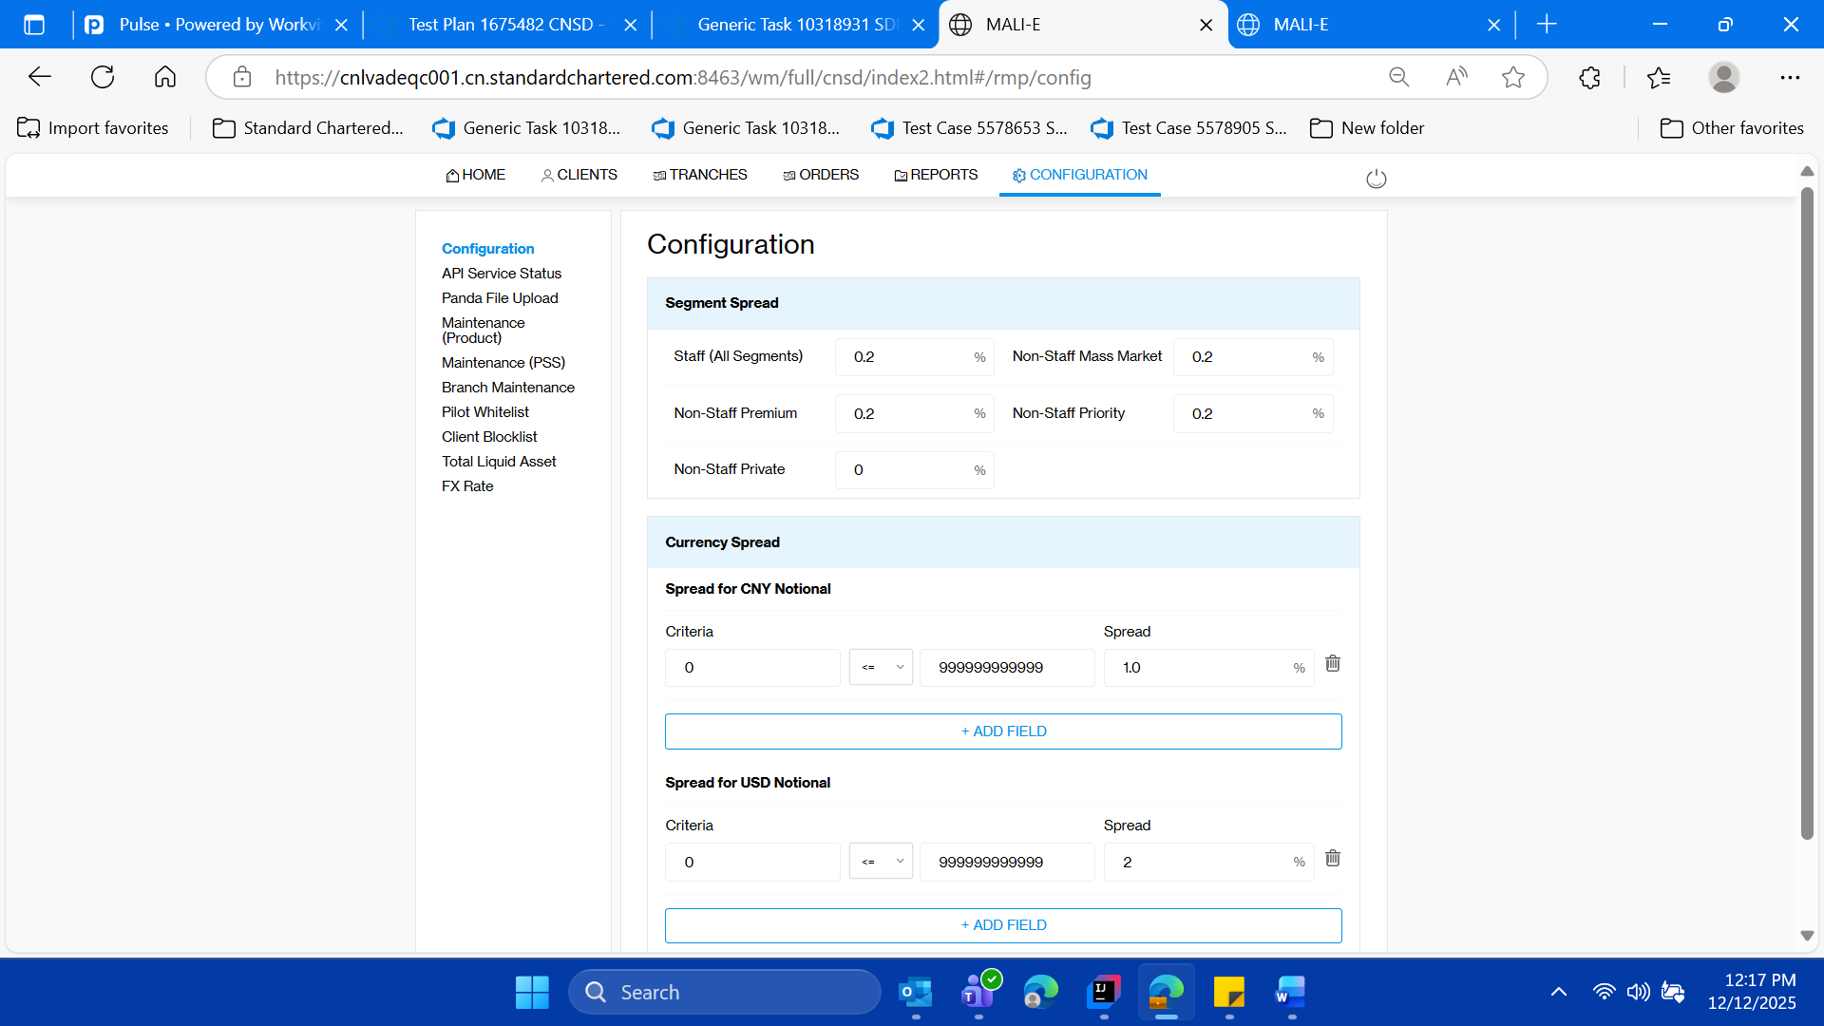

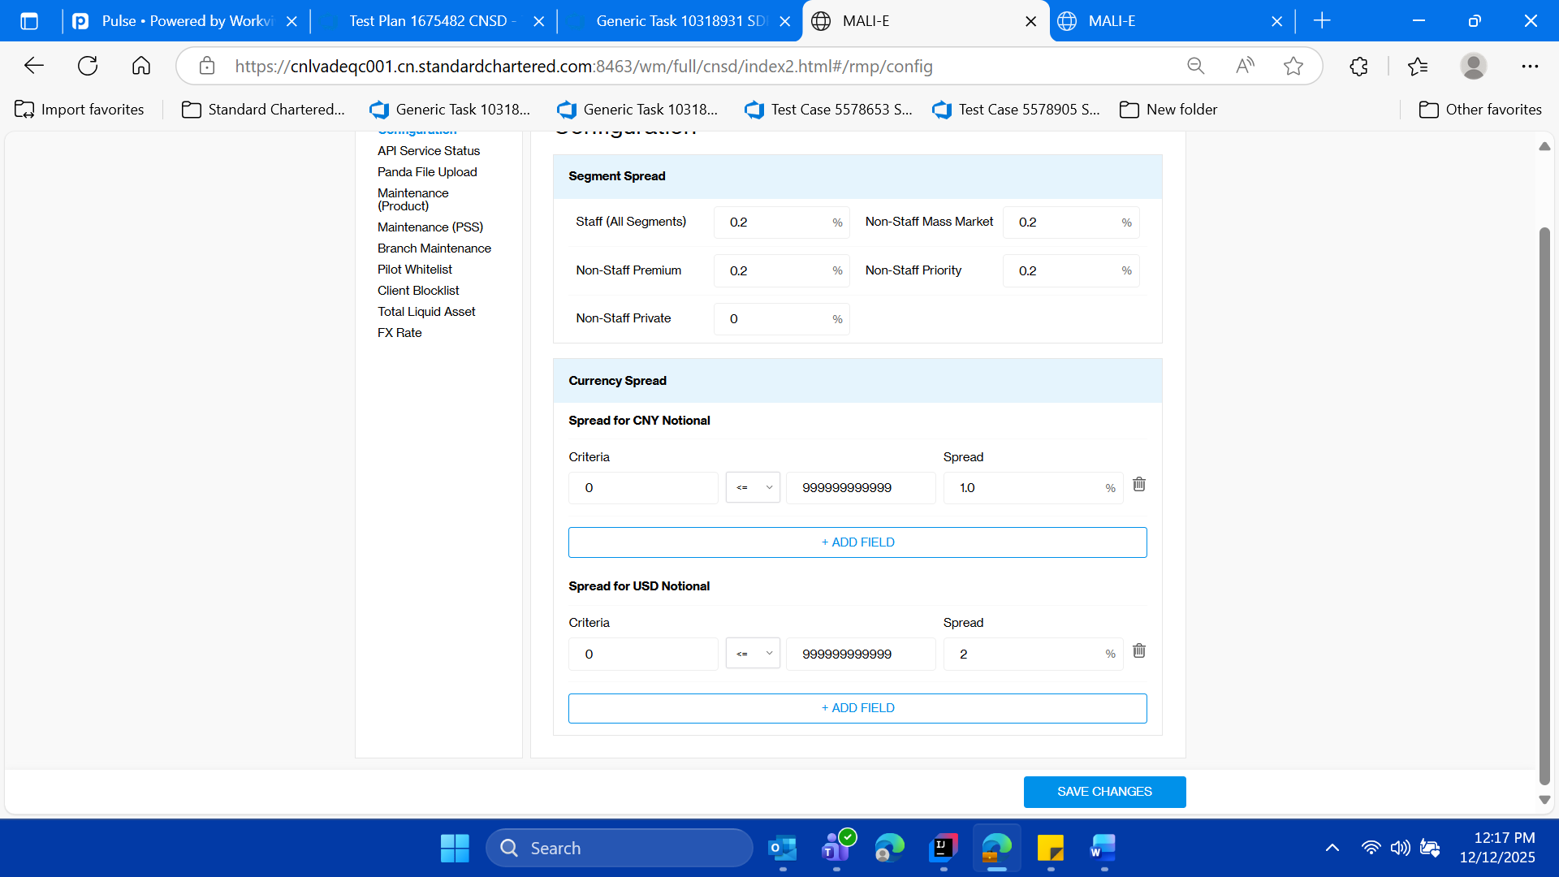

* **Click on the “Maintenance (Product)” left menu and validate the tilt e of the page as “Maintenance (Product)”**

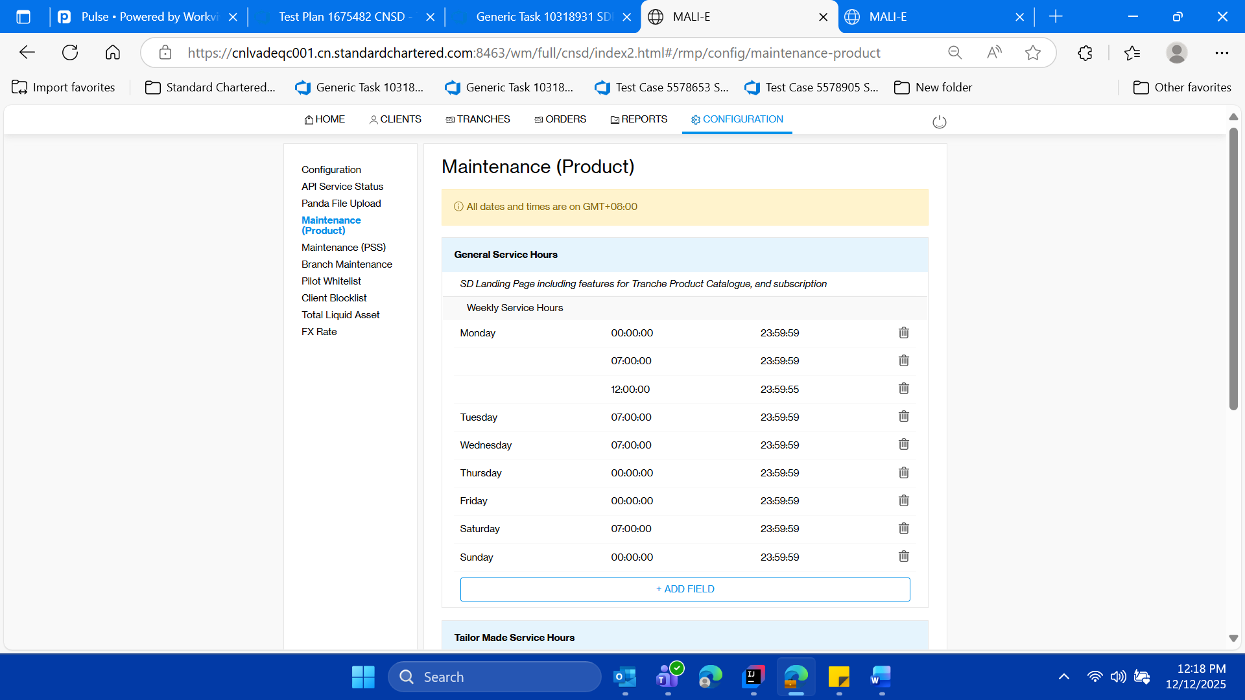

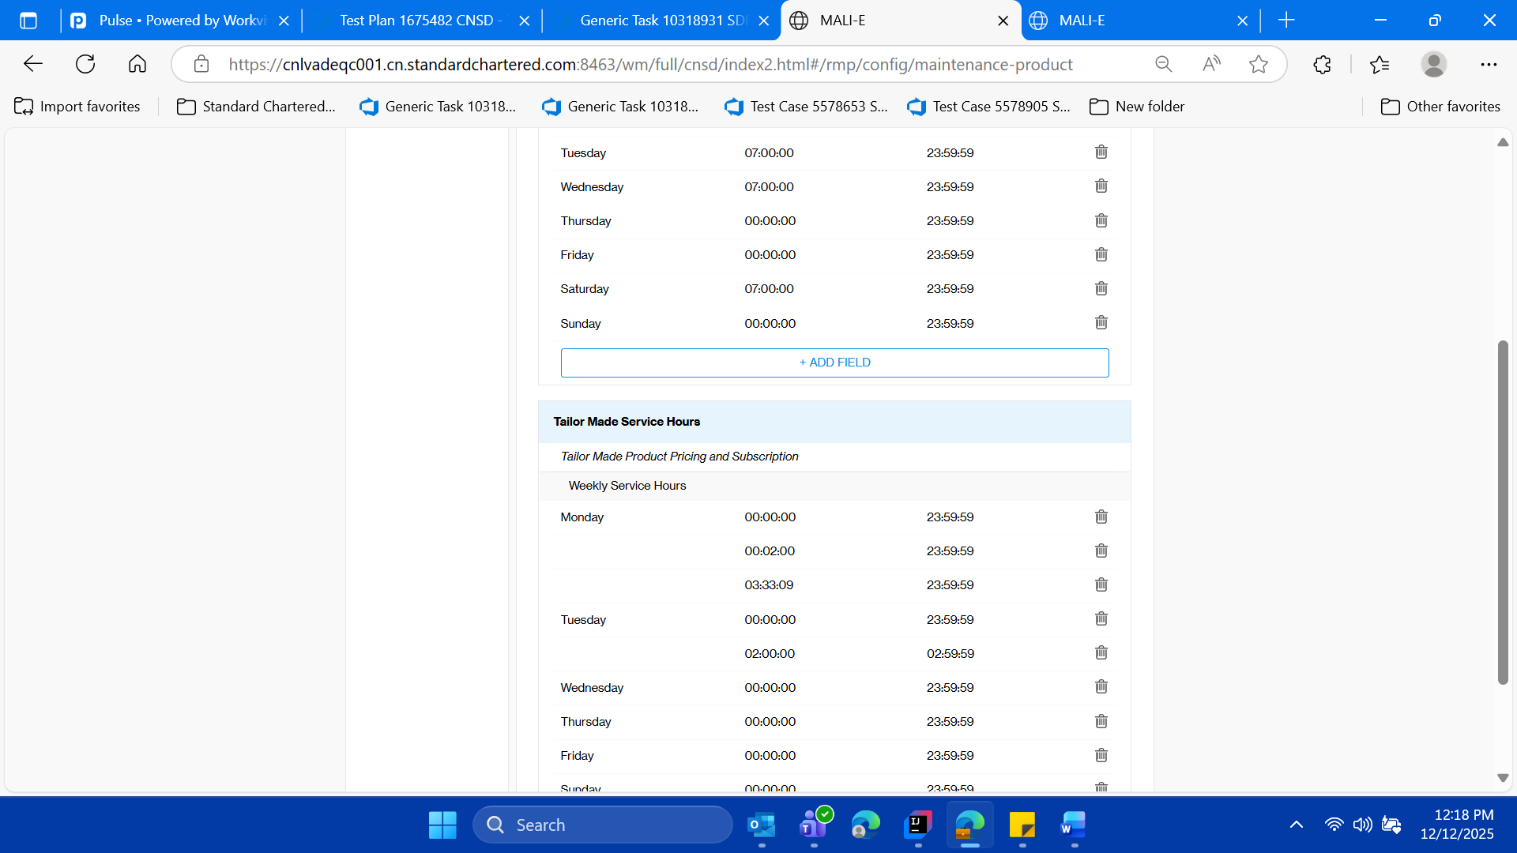

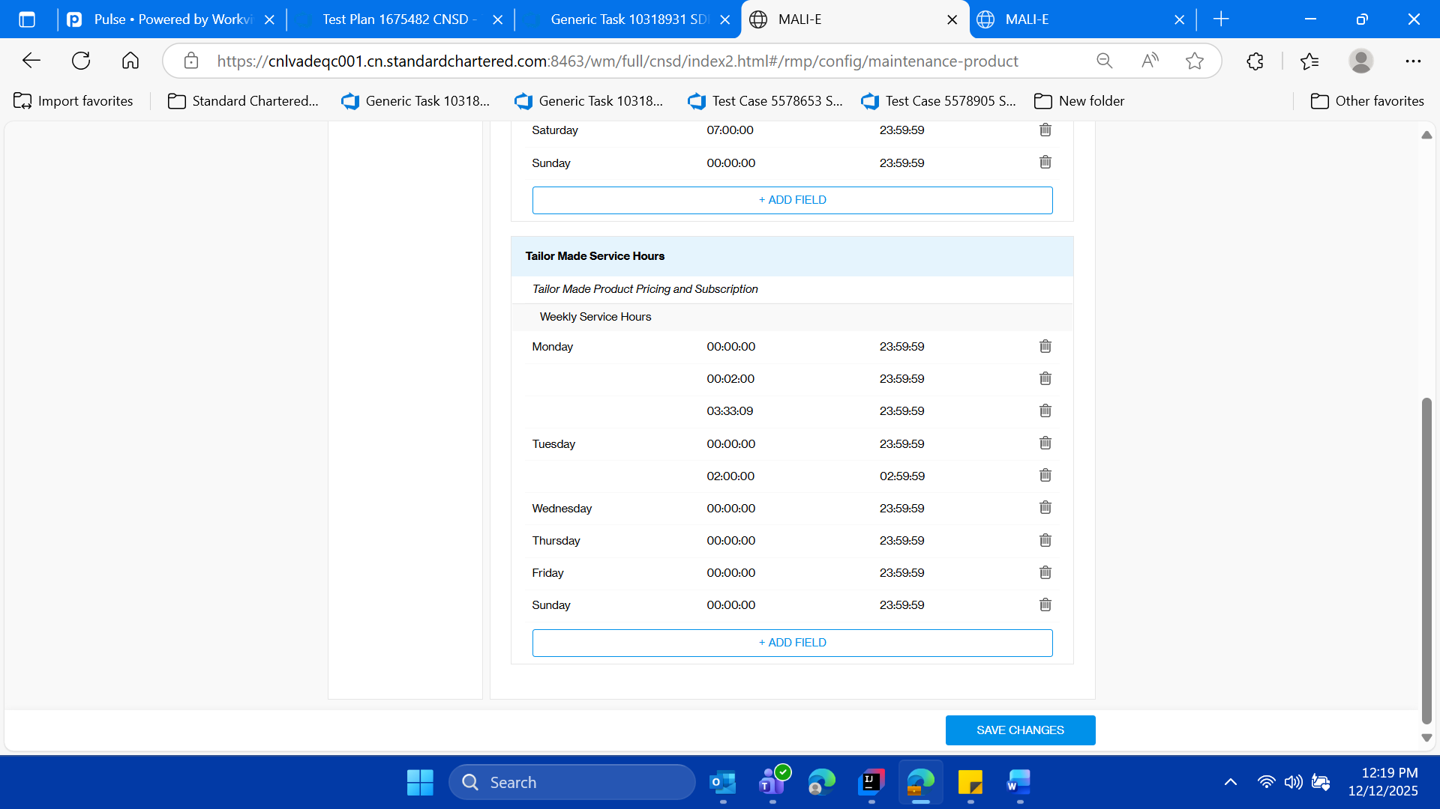

* **Within this “Tailor Made Service Hours” section of the page, keep the note of “Start Date” and “End Date” for current day of test case execution**

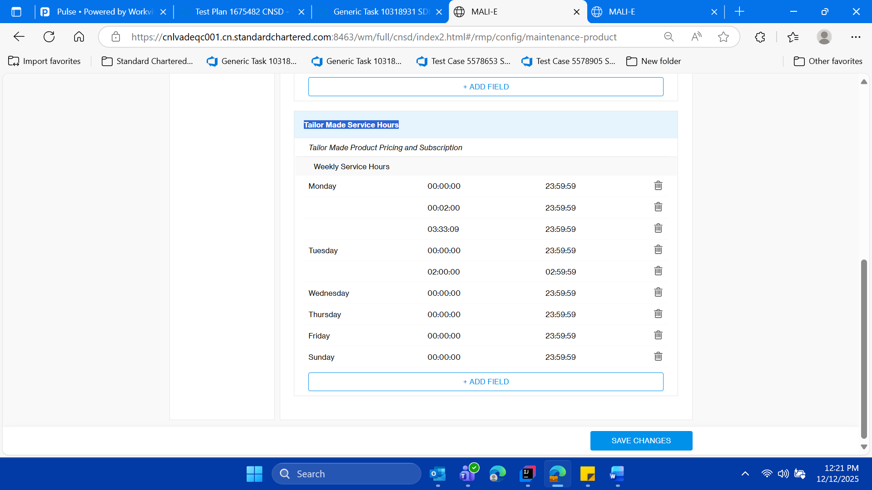

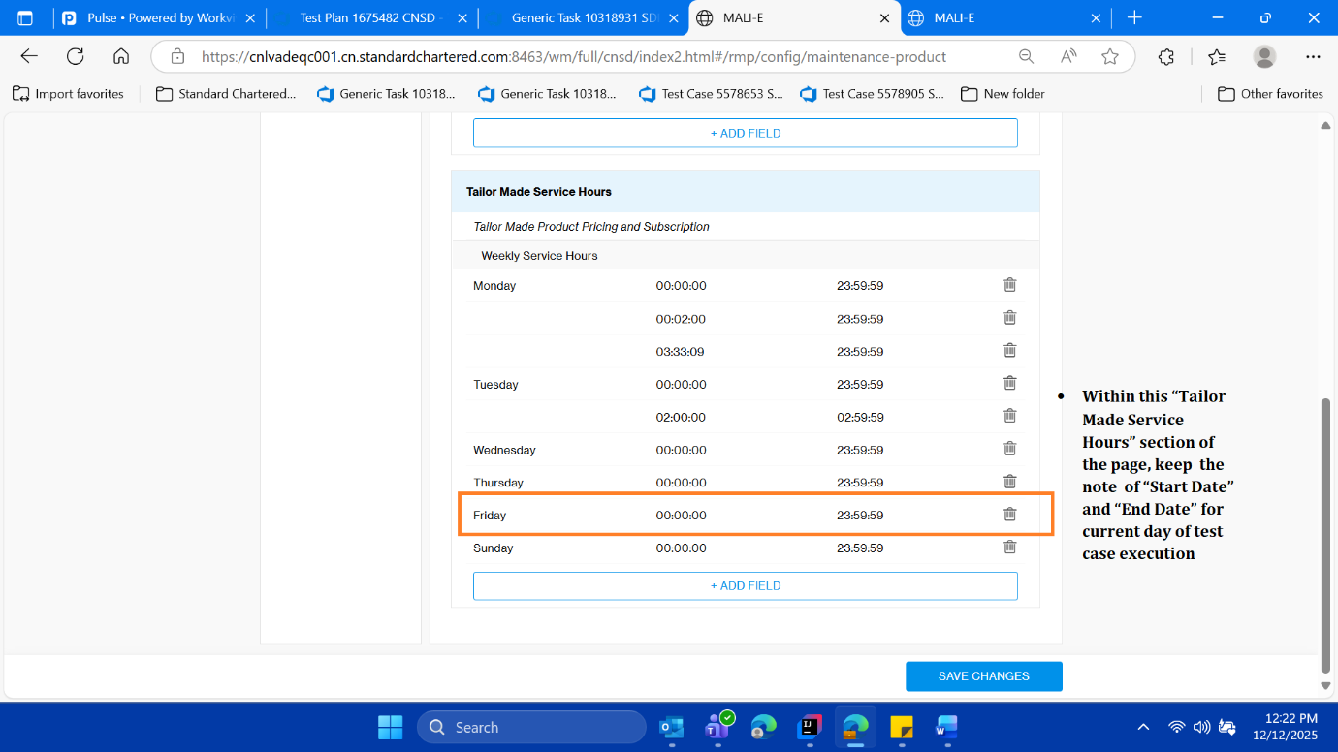

* **Now delete the current day row with the help of delete button**

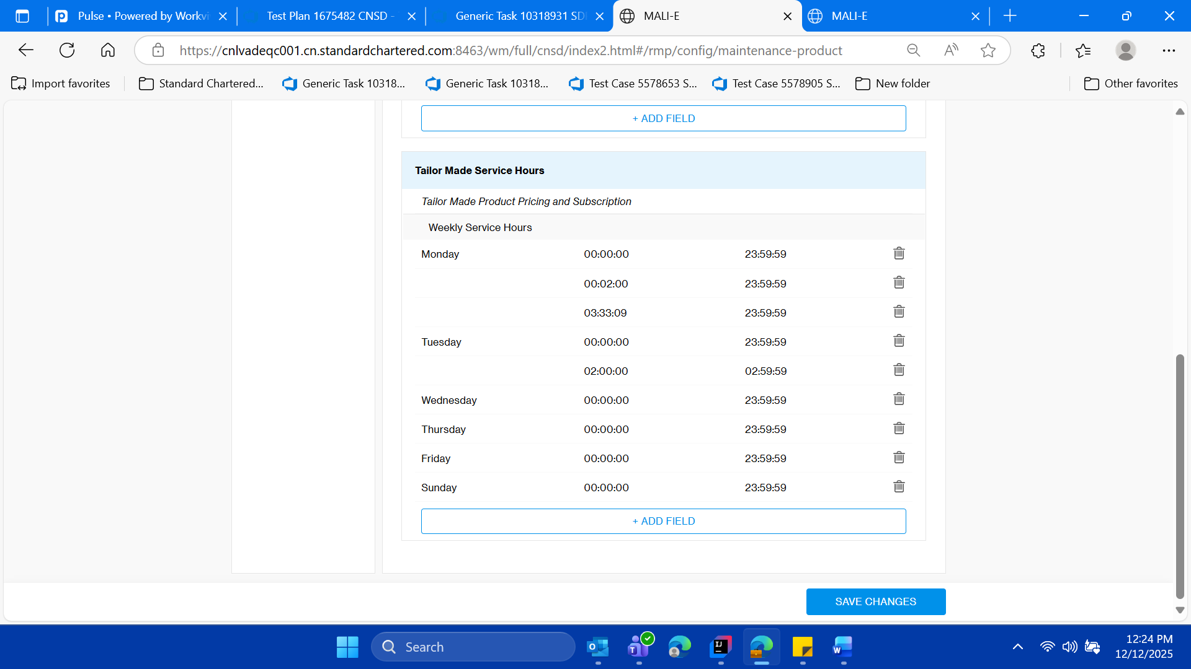

* **Validate the current day data got deleted**

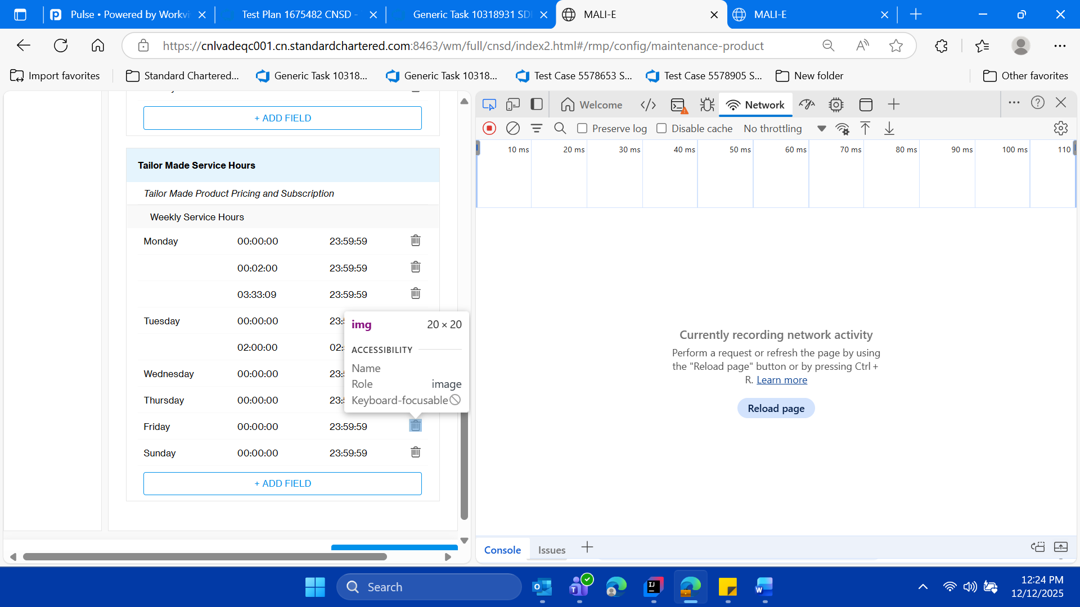

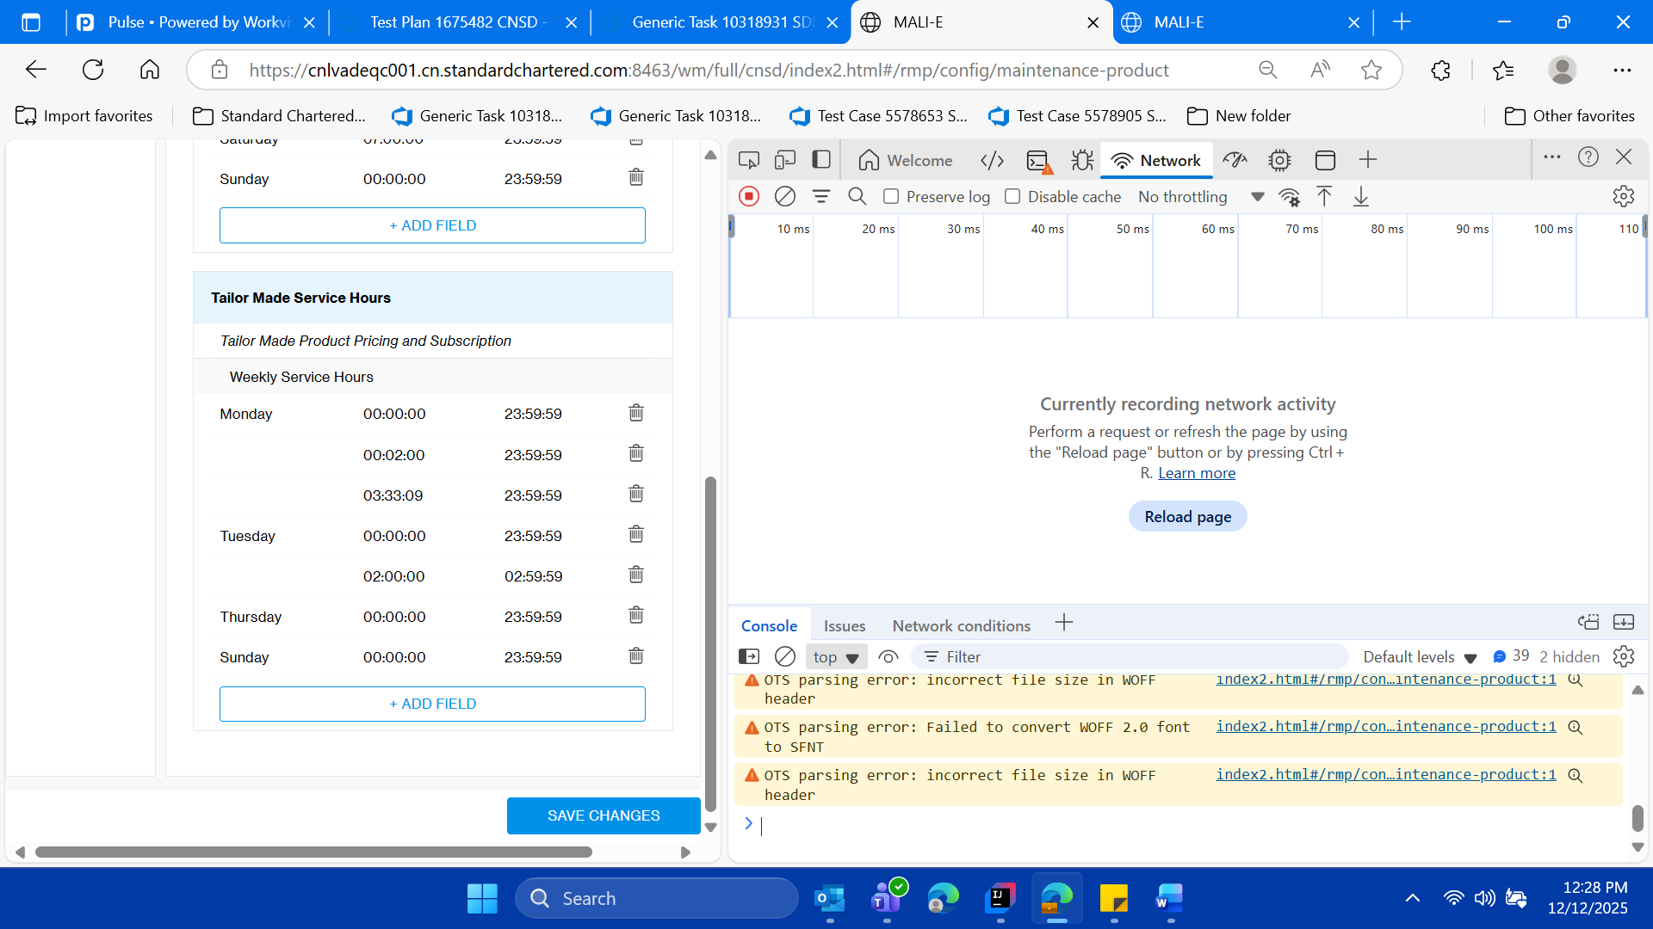

* **Click on Add Field button and add the current day data from the dropdown of newly adding row**

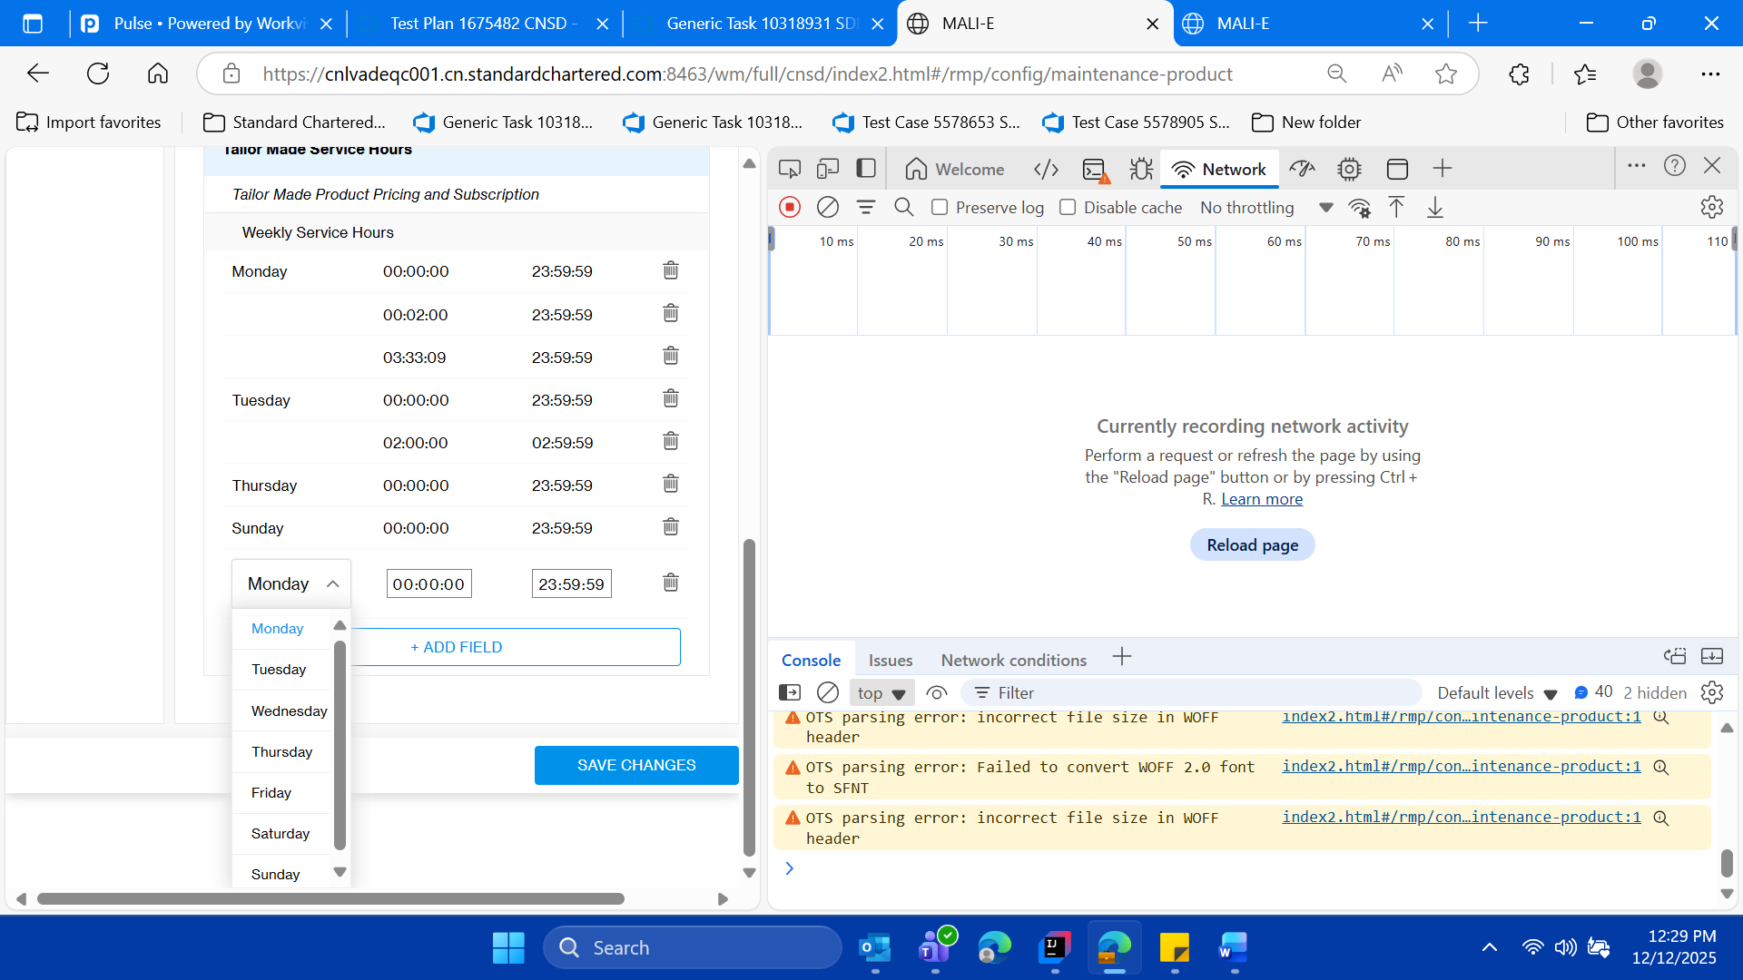

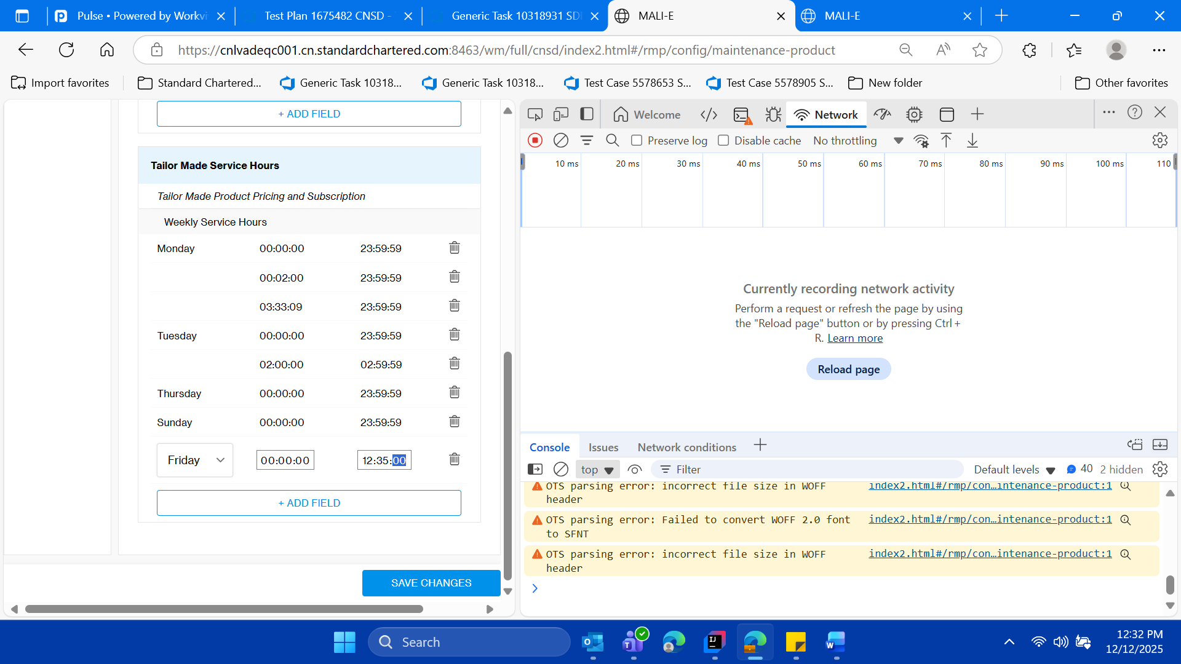

* **Change the time as per the hong kong time on the office laptop (on the day and time of execution of test case PFA ss) So lets make it 12:35 pm , and currently its 12:32 PM**

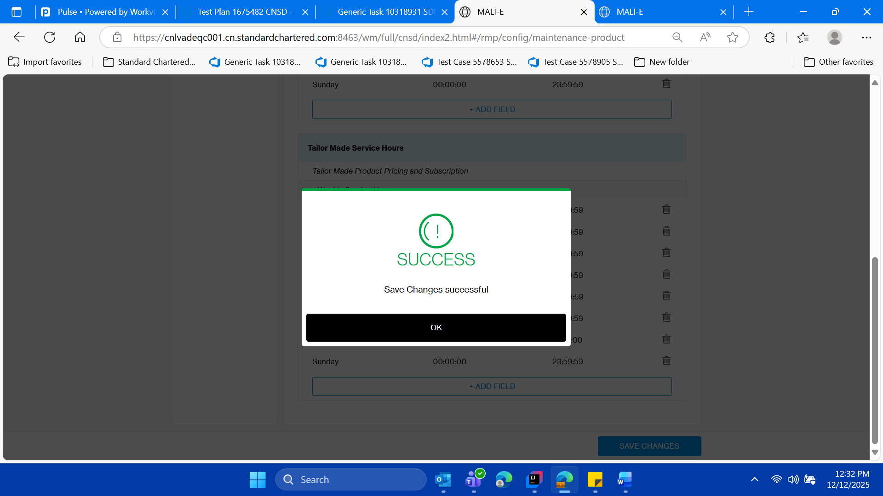

* **Click on save changes validate the success message**



* **Click on ok button on save success message.**

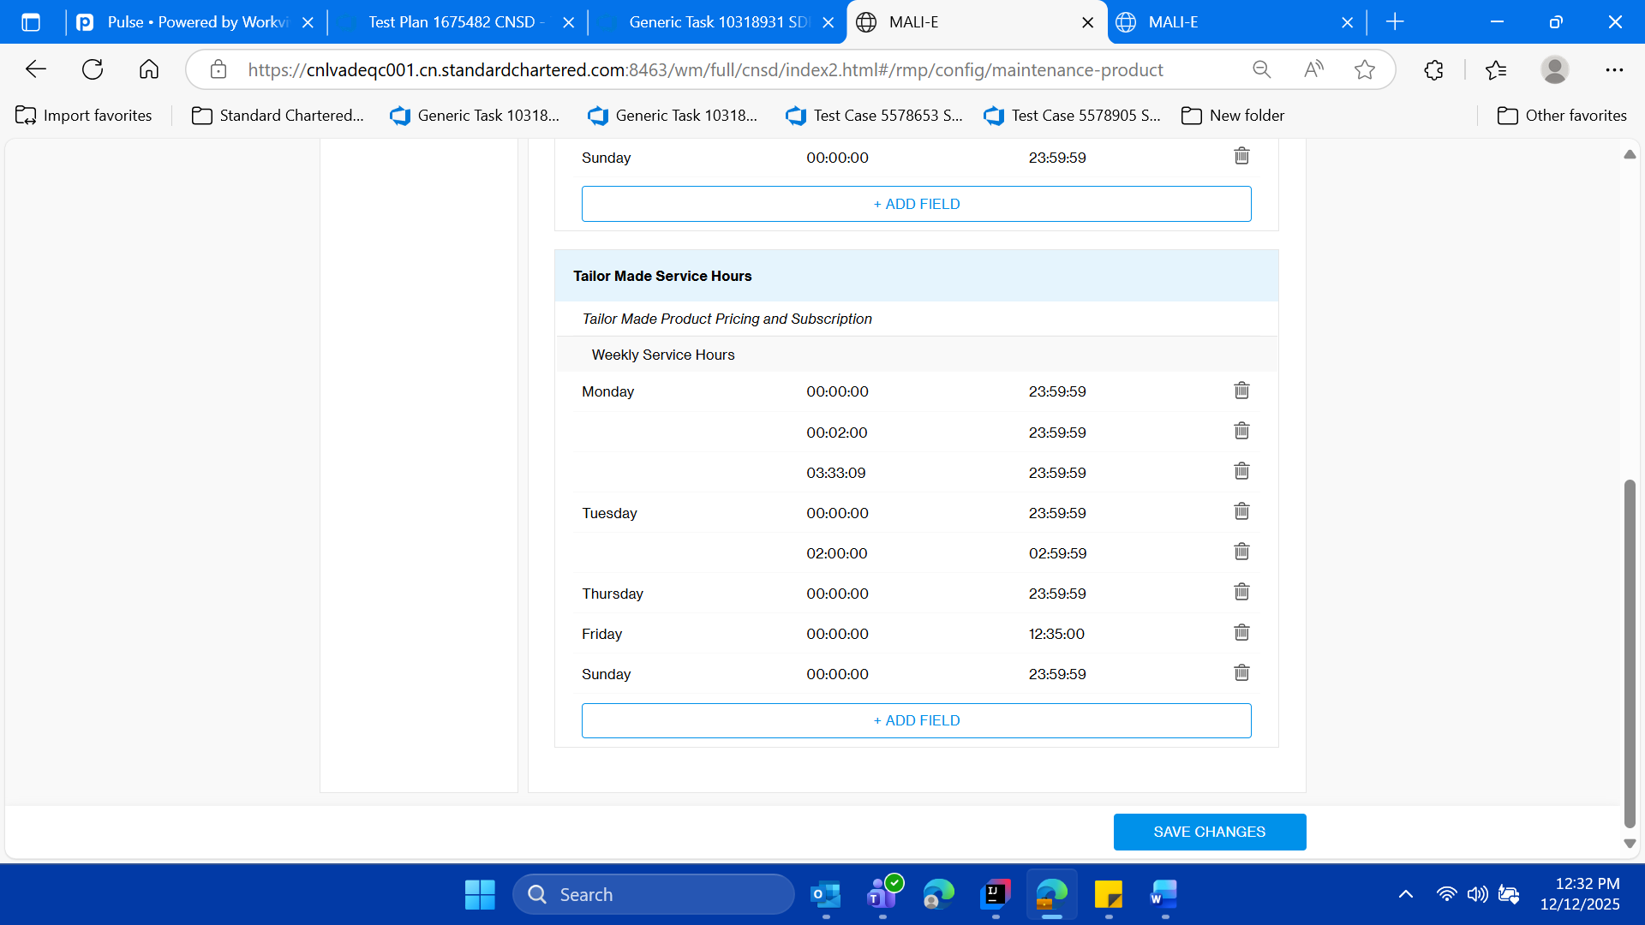

* **Validate the upaded times**

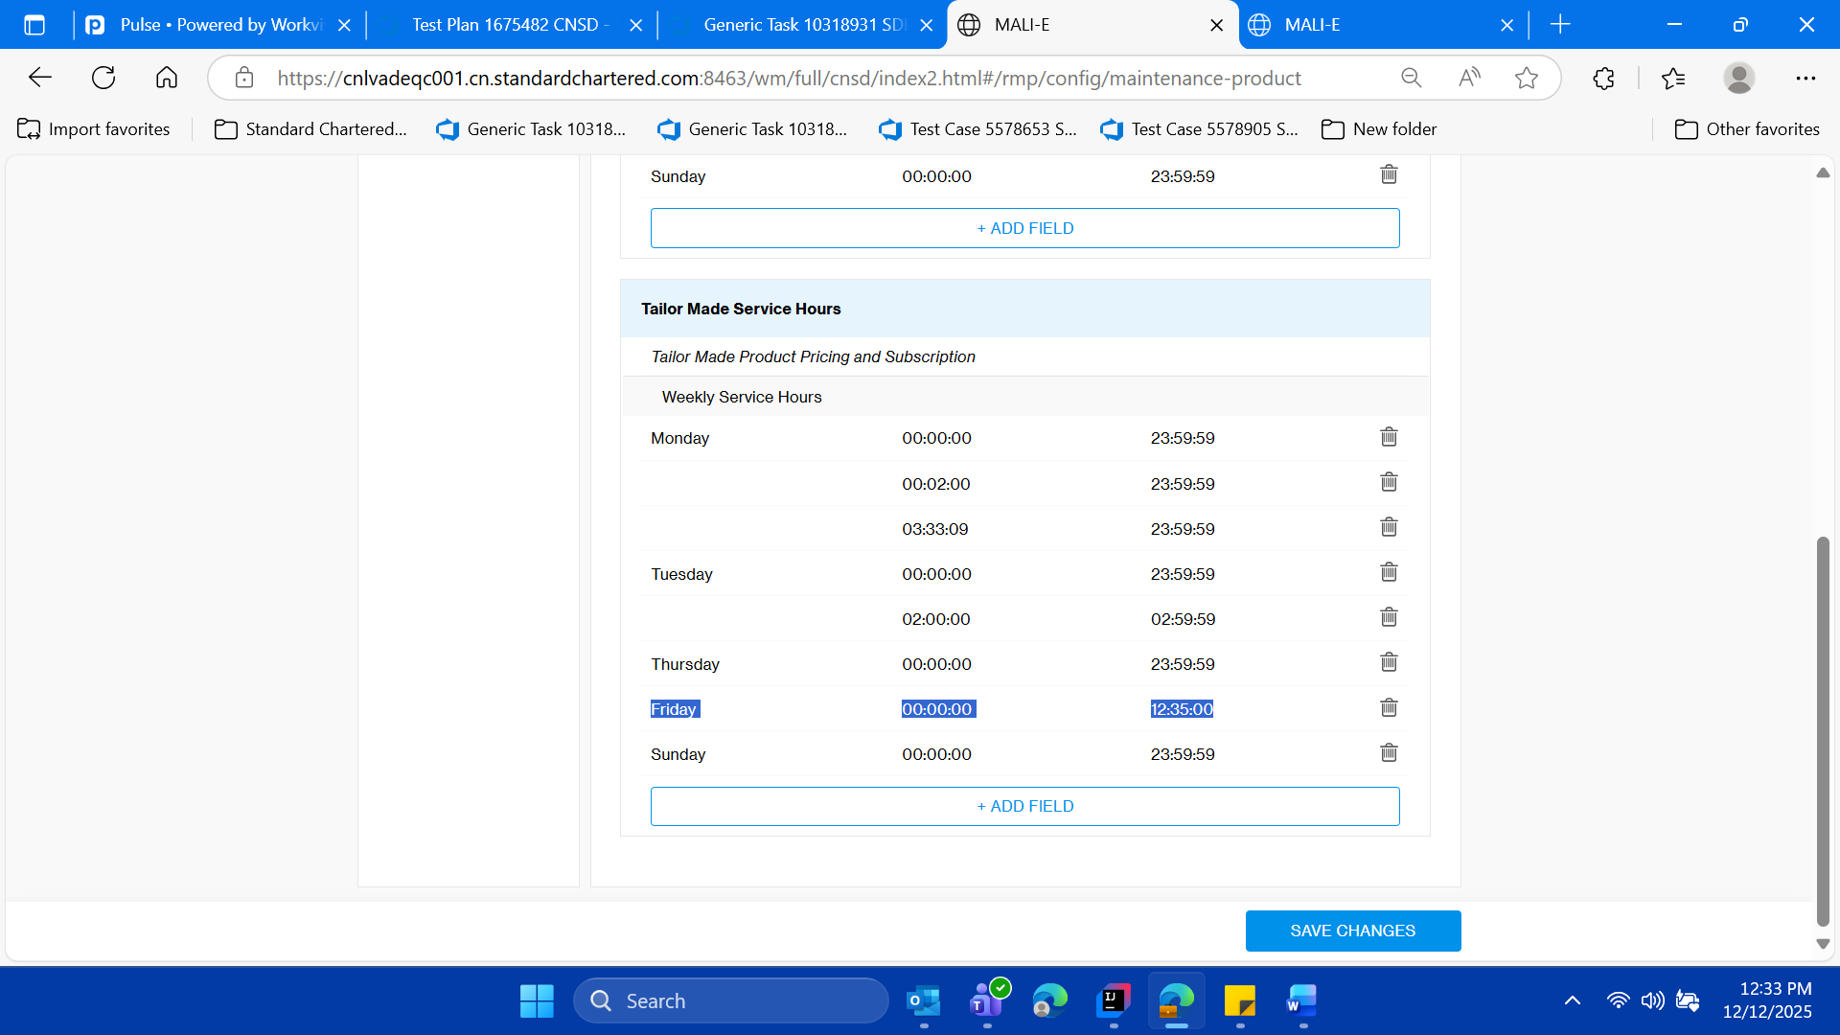

* **Login to sso mock, and user should be able access the Tailor section in SSO MOCK only between “00 am to 12:35 pm” as per the honk kong time**

**And out of that time and user will not be able to access this section “Tailor-Made Structured Deposits**

**” on SSO MOCK home page**

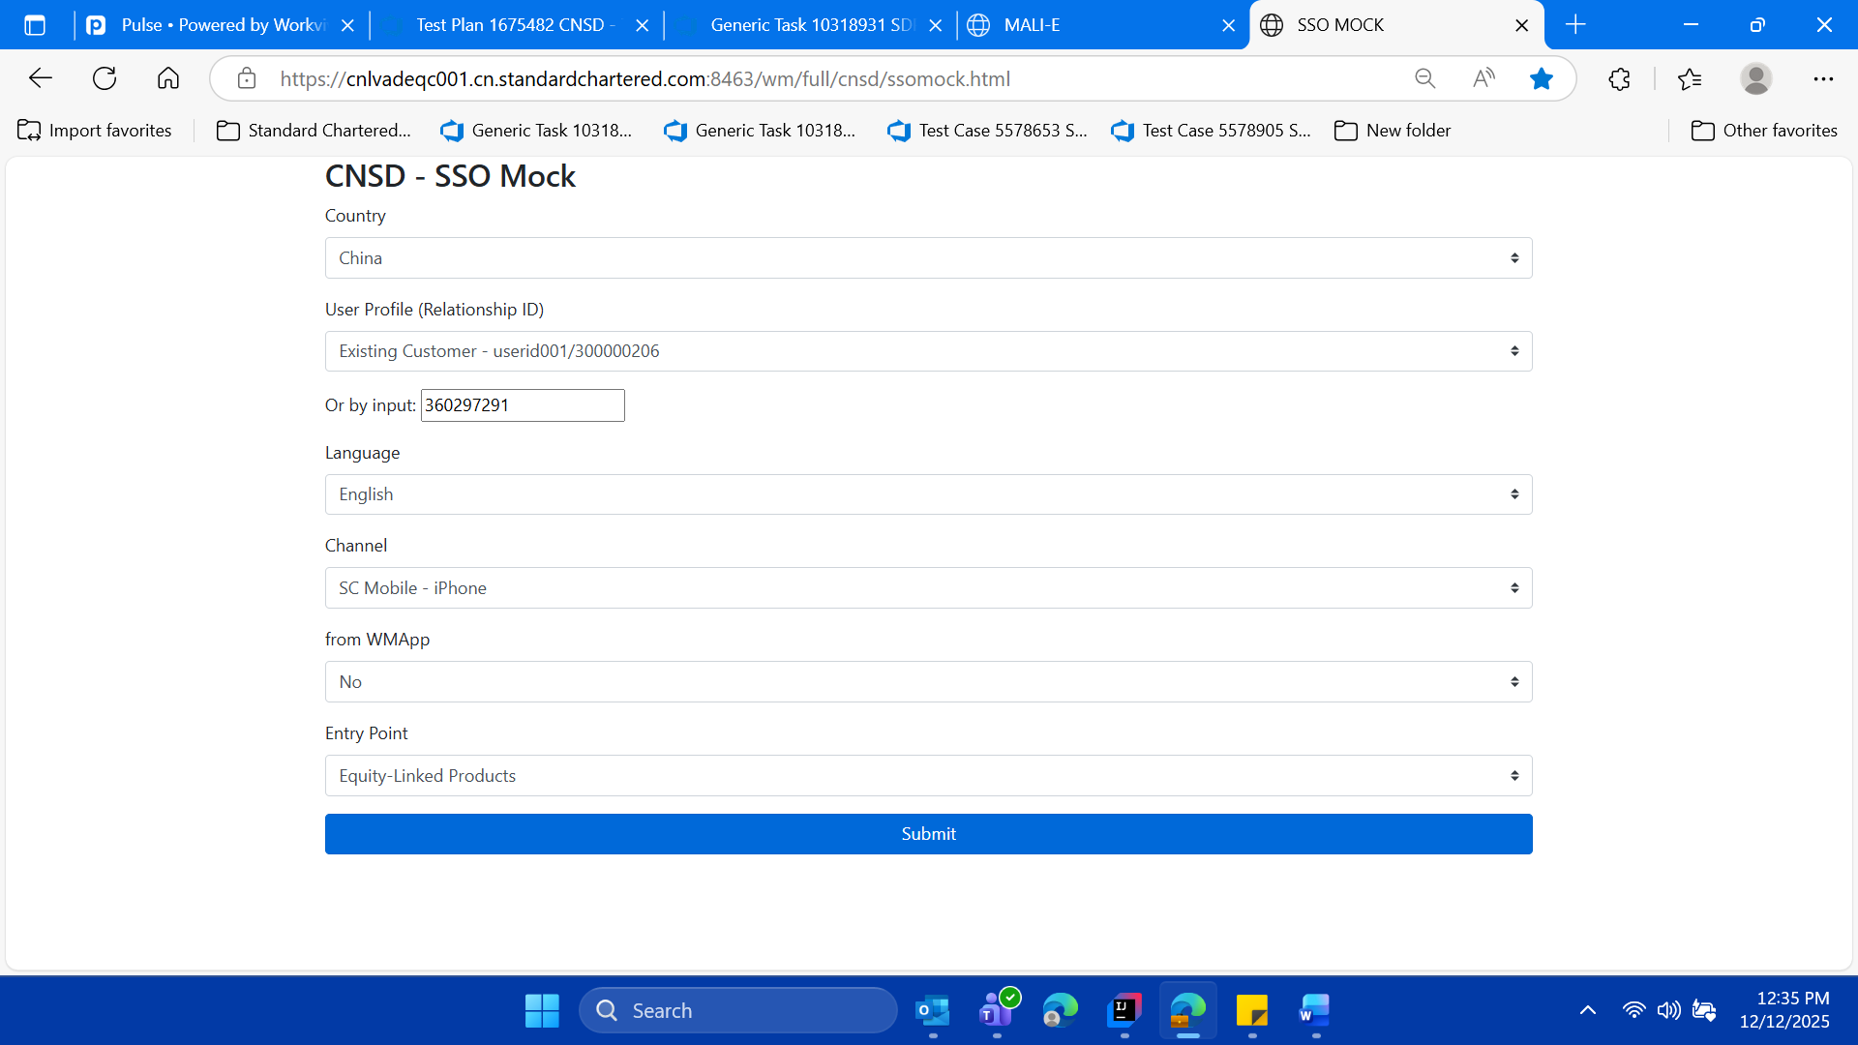

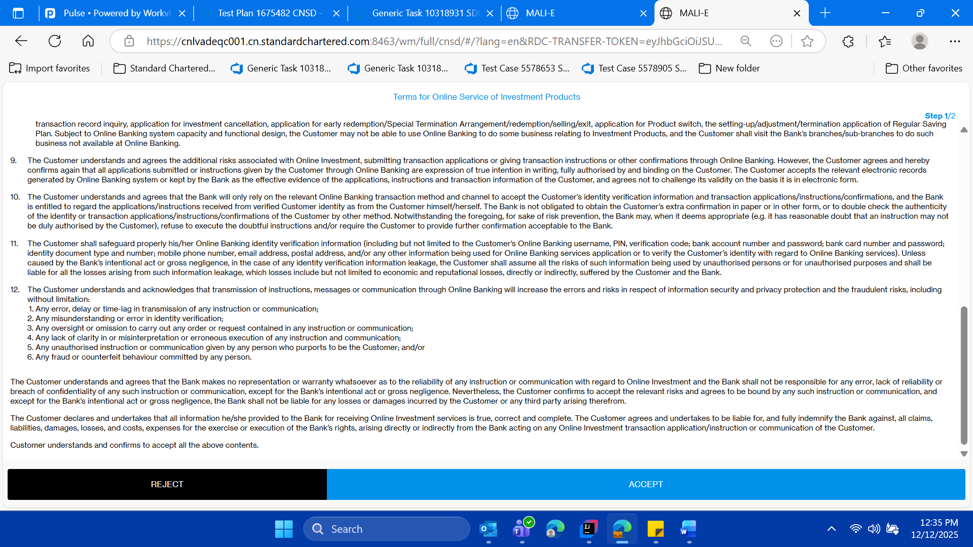

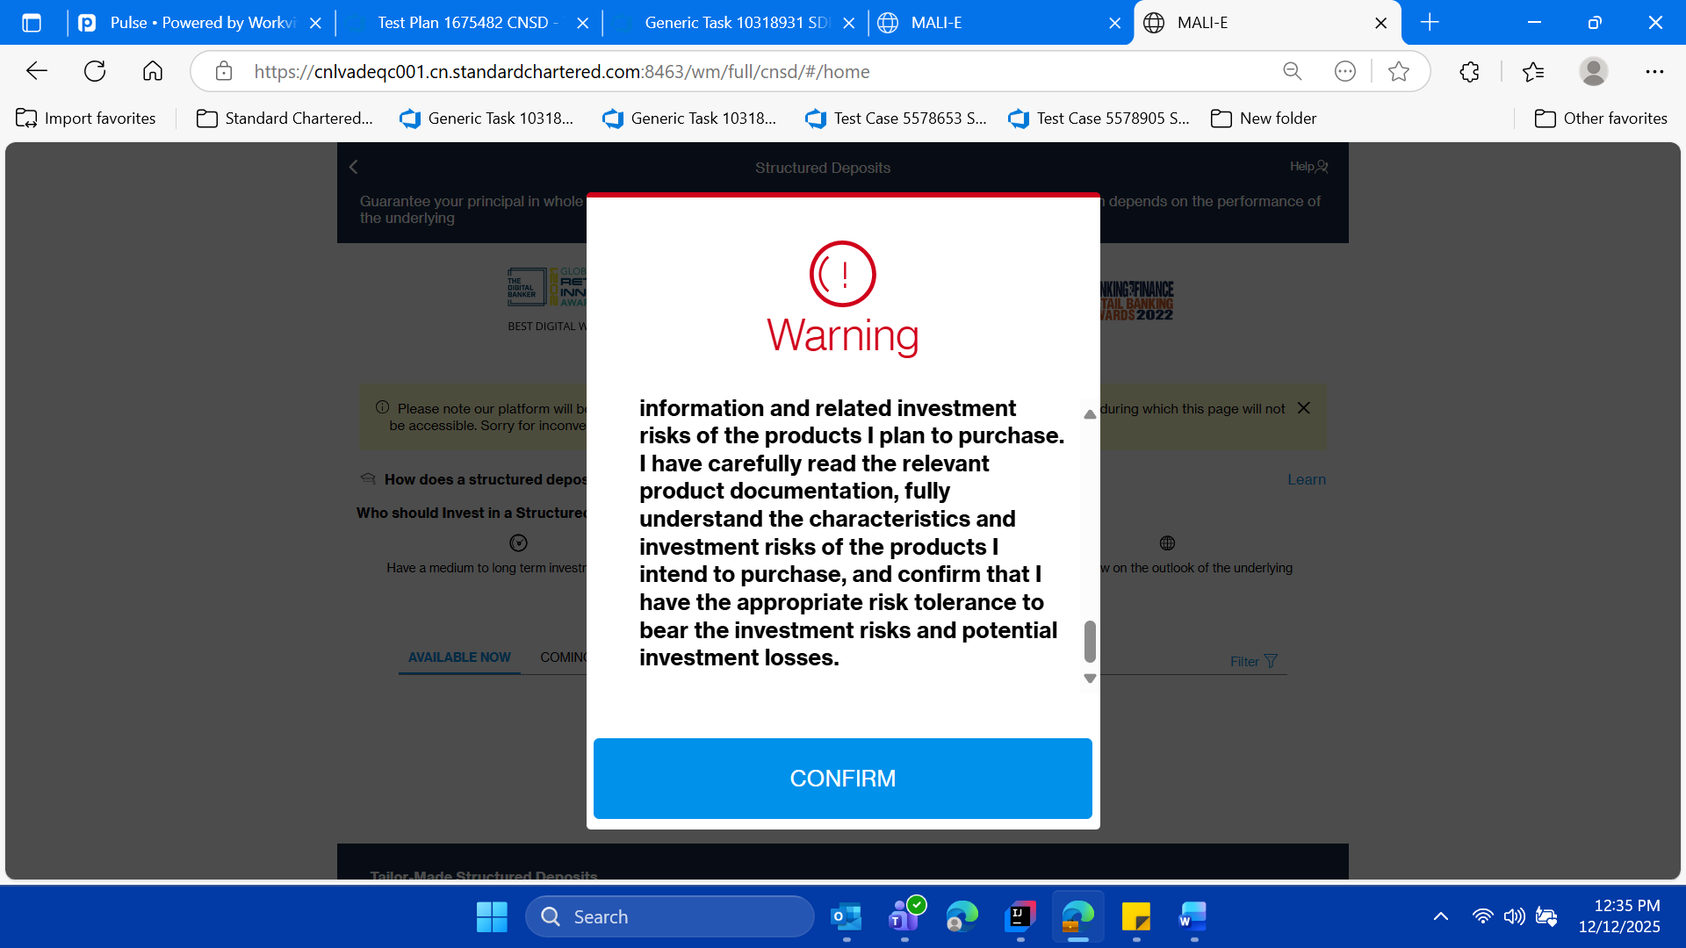

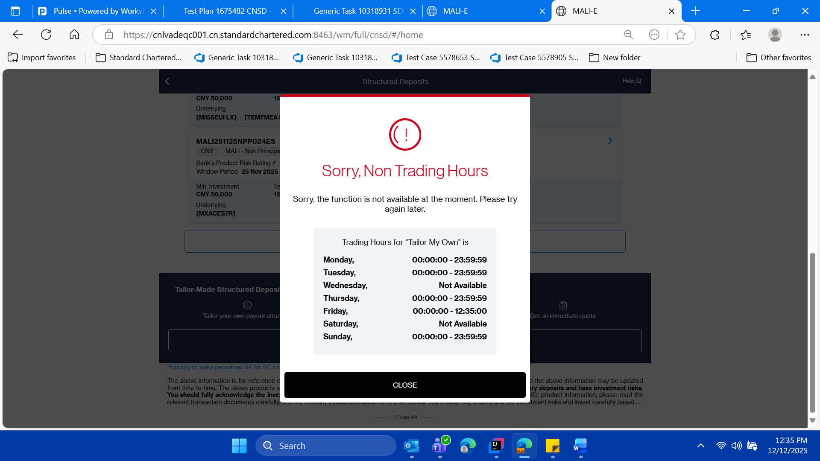

* **Validate the pop up of tailor for current date and time that we have set in the Mainatiance page in SD Portal for this SSO MOCK tailor..**

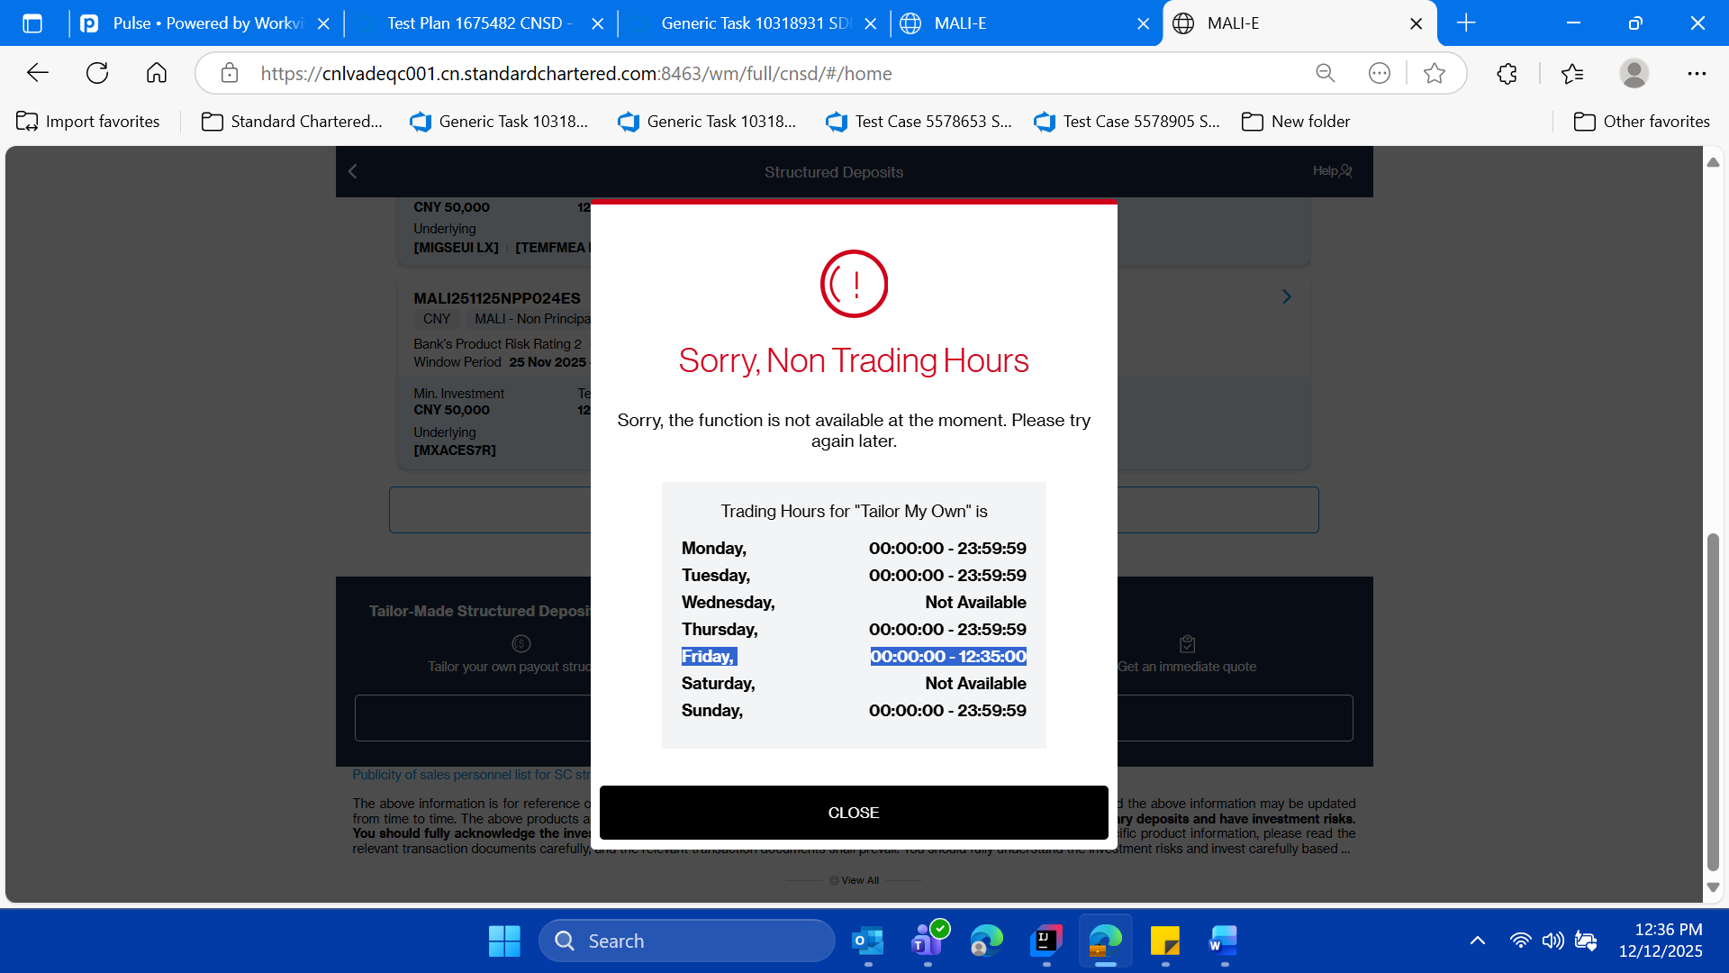

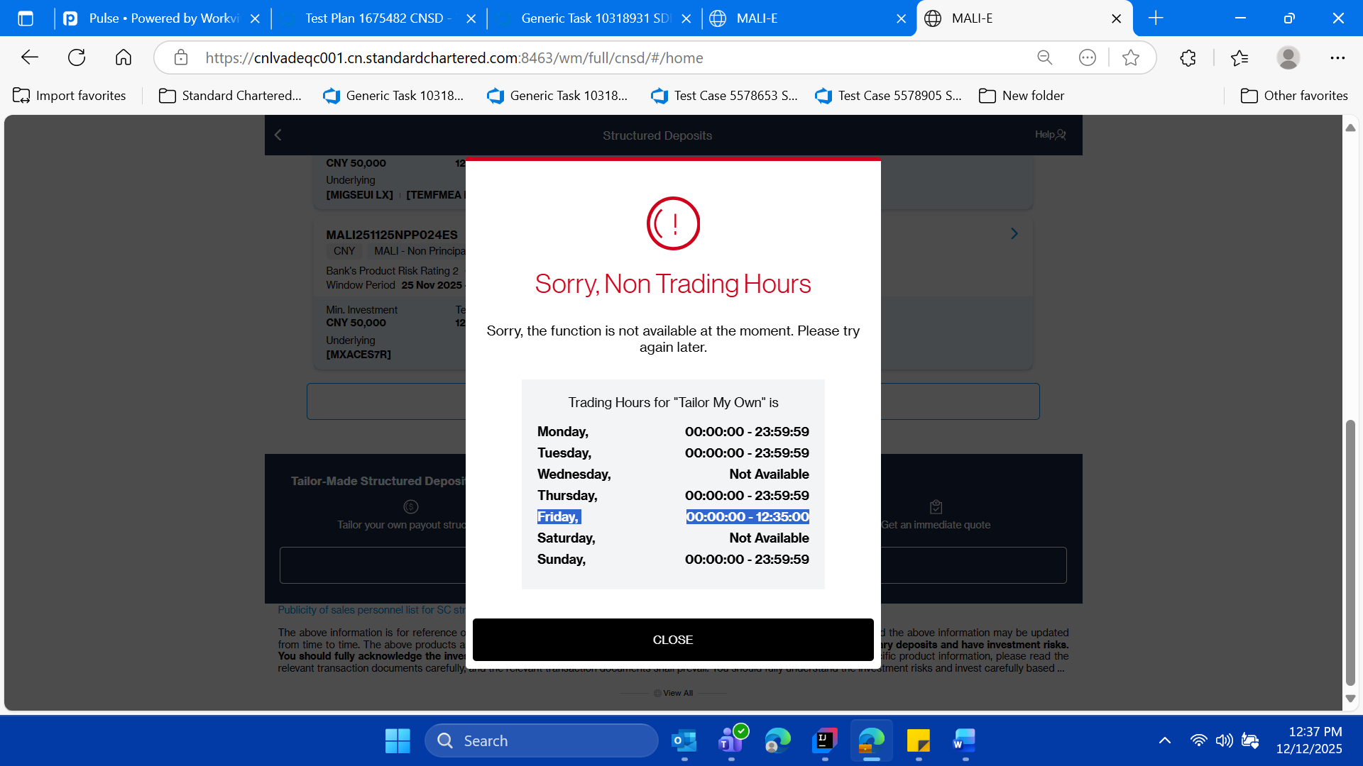

* **Now close the pop up on in SSO mOck, validate user lands on the home page(product catalogue ) page of SD portal**

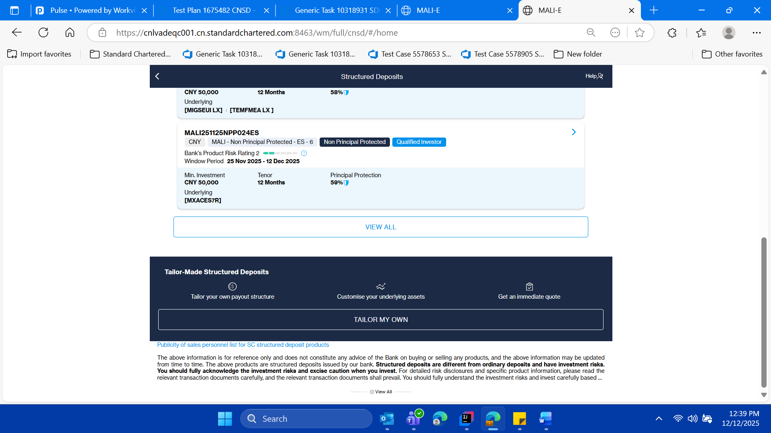

* **Click on the back button and logout of the SSO Mock application in tabbed given window**

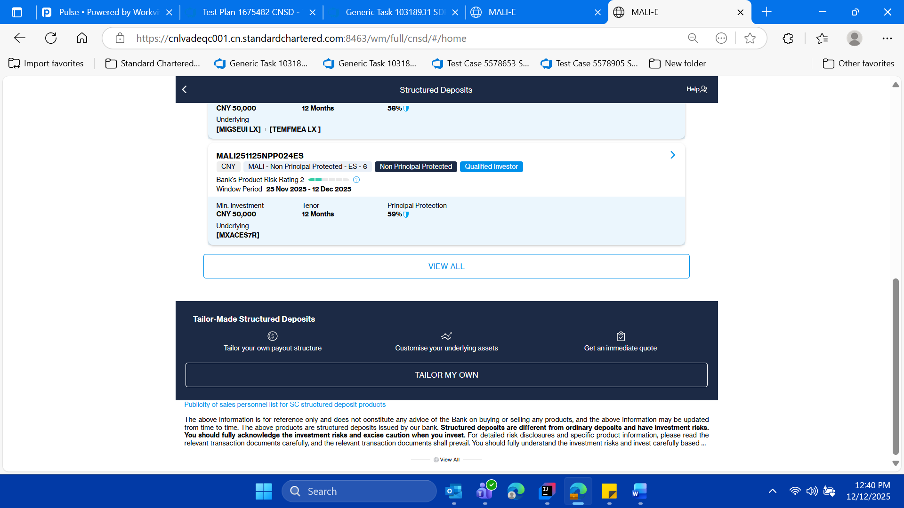

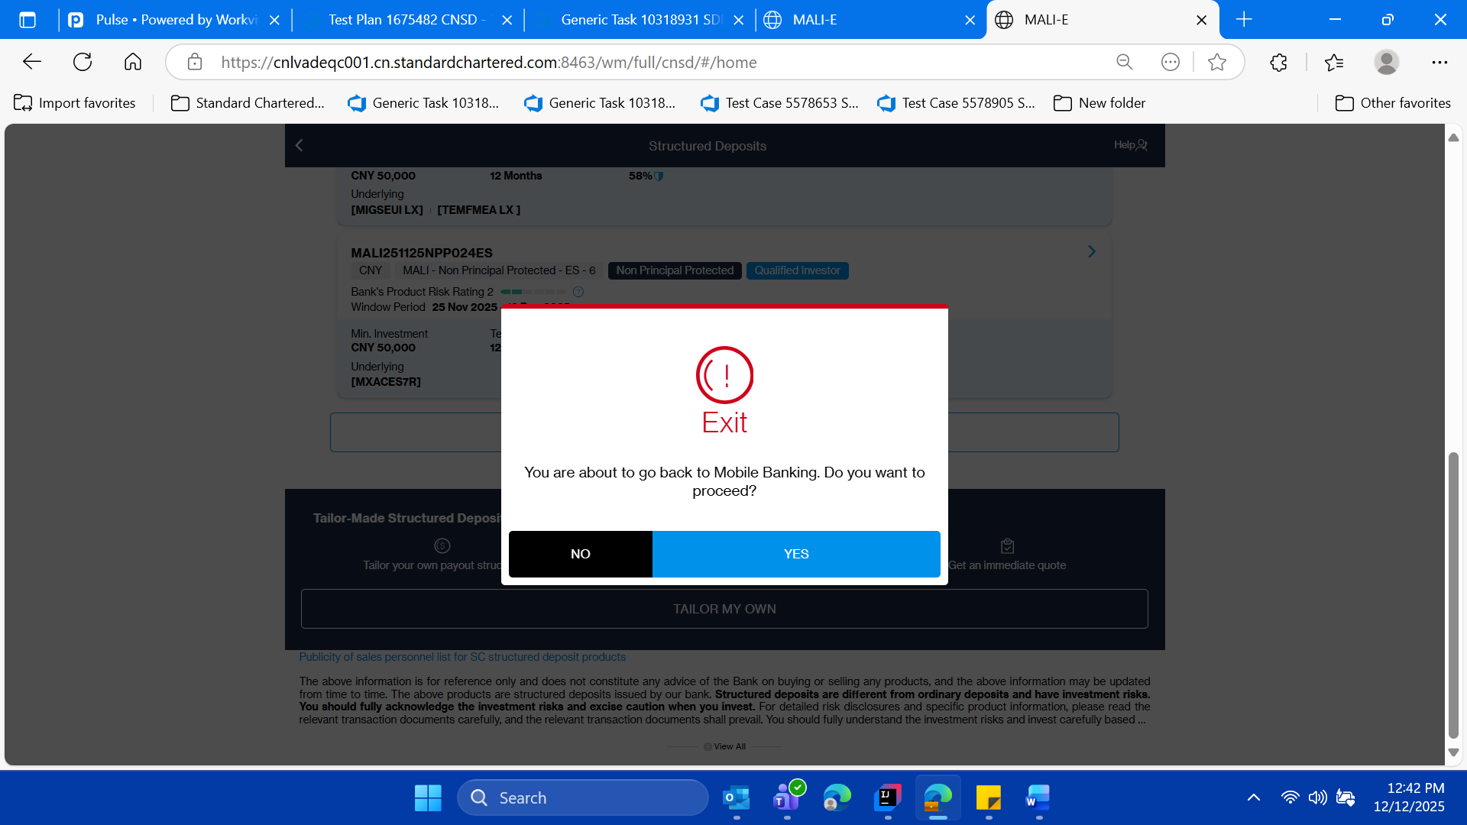

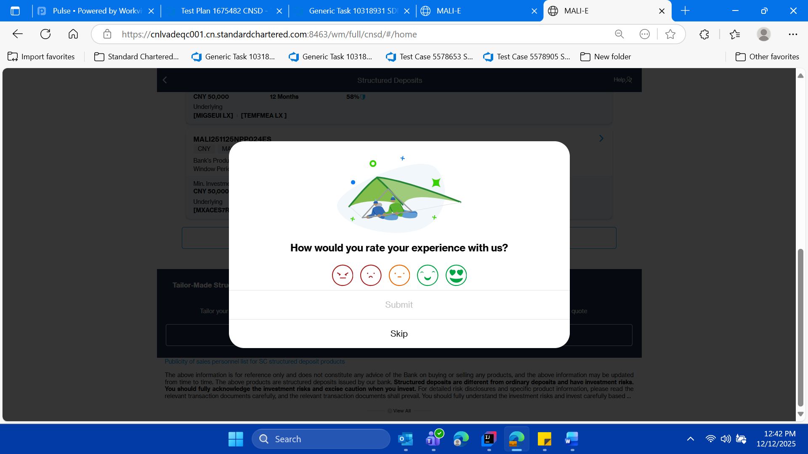

* **Click on skip**



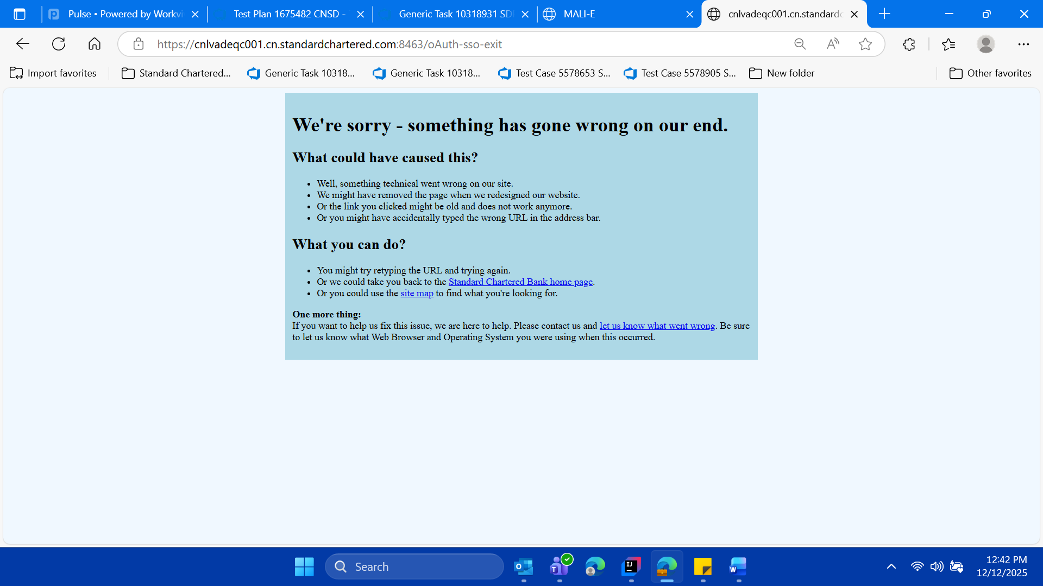

* **Now switch back on the SD Portal parent window ,**

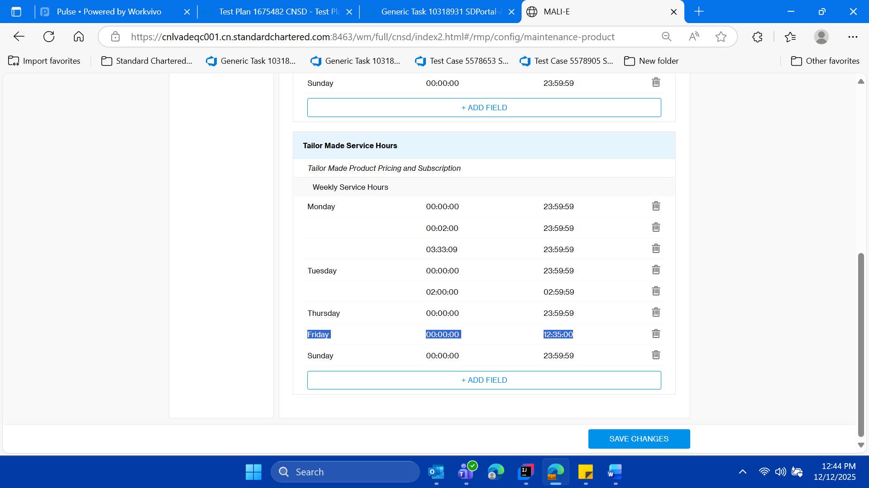

* **Convert the current day (Friday), from and to date , in the format , it was there previously before the execution of this test case for tailor section**

**-So basically converting the application the default state**

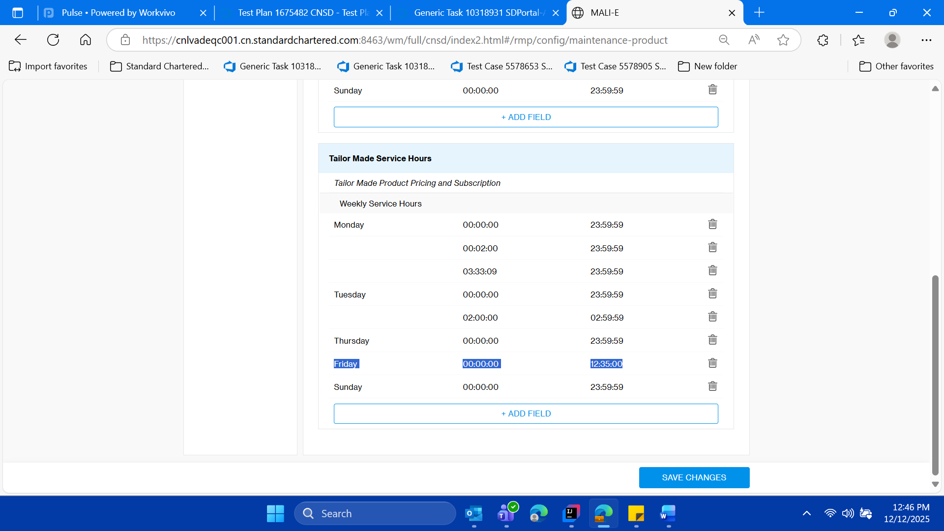

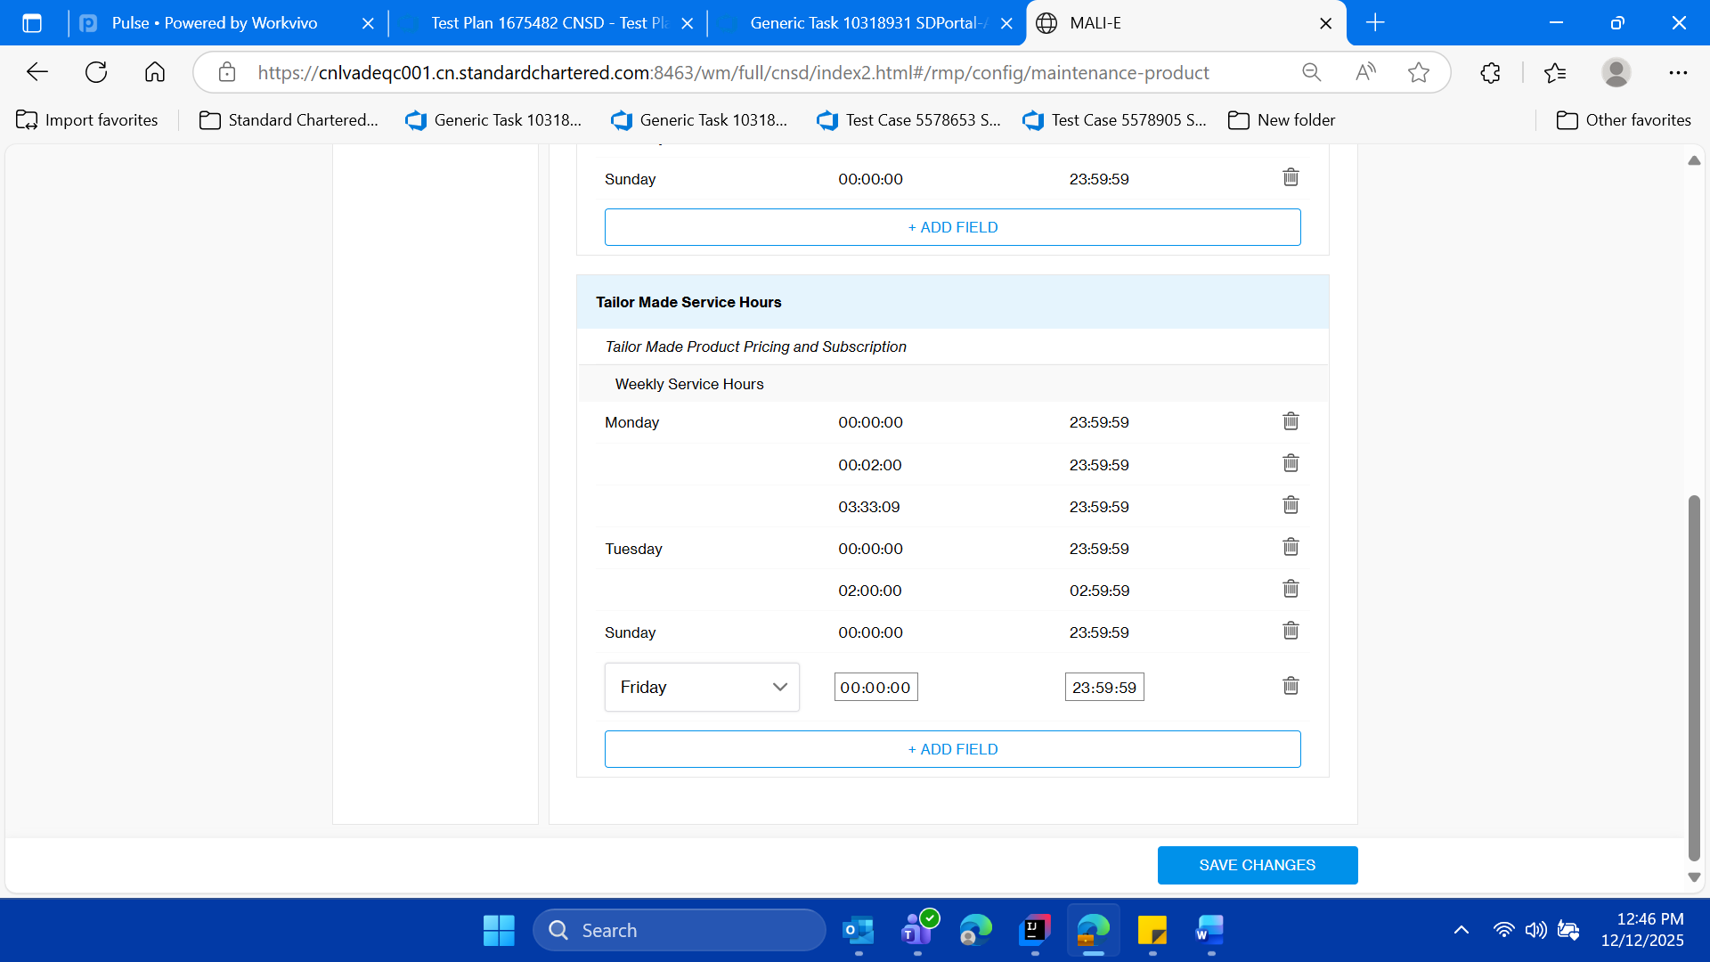

**Vliadate success message**

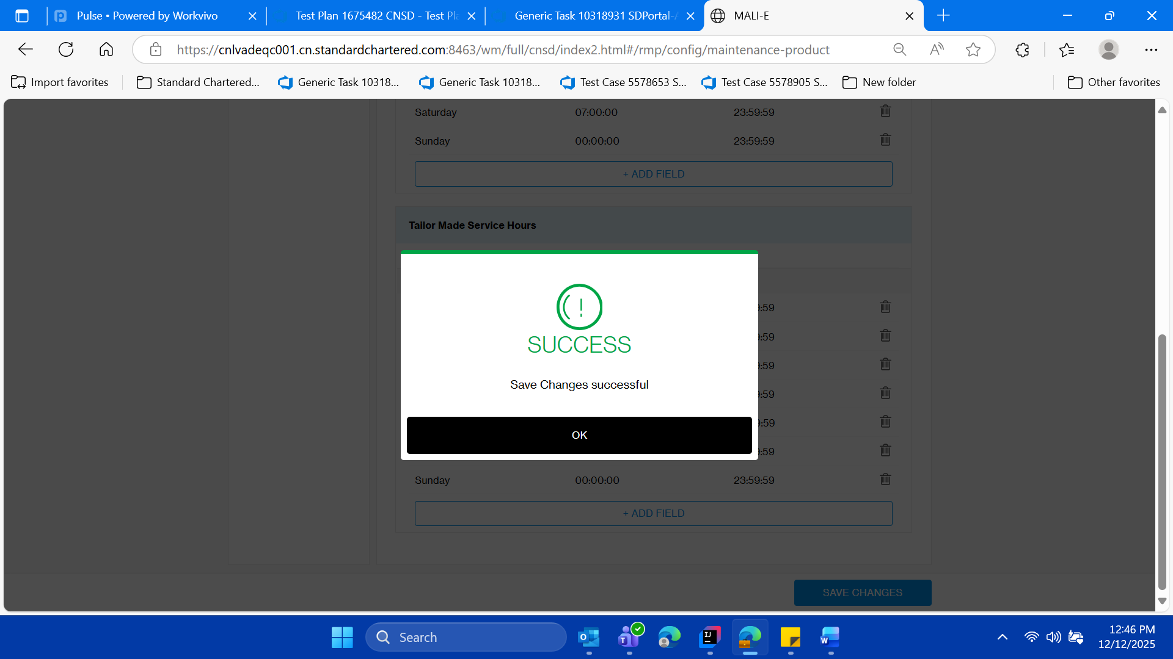

**Validate the dation of time and day as per default current day and date**

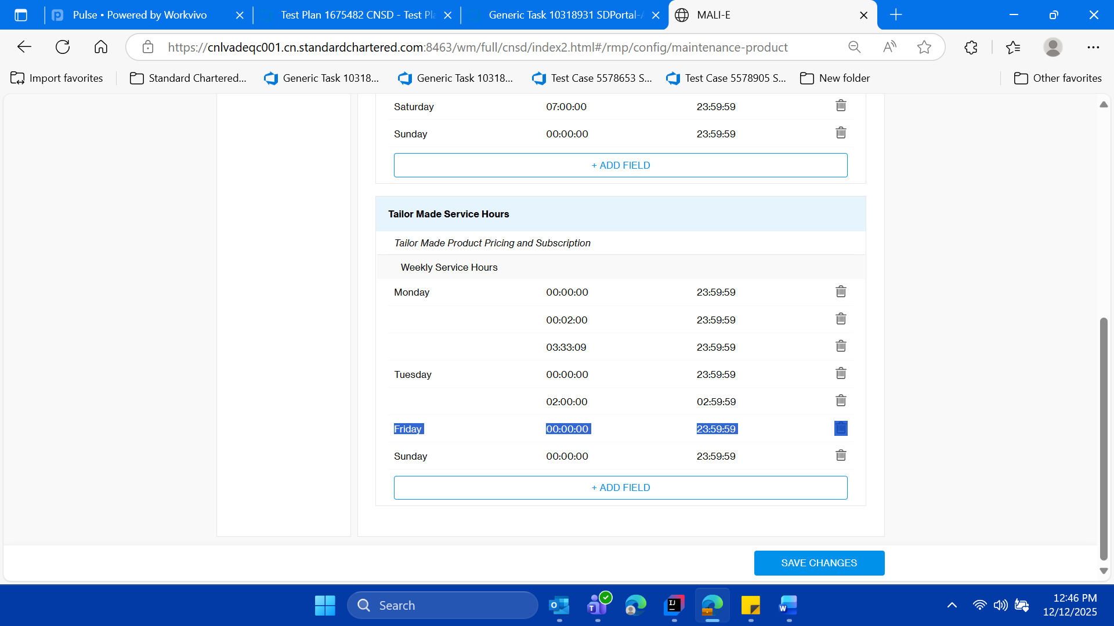

* **then logout of the SD Portal close the parent window of SD Portal**

